

**A**

**PROJECT REPORT**

**ON**

**NEWS WEBSITE**

**AT**

**“Radiant IT Services Pvt. Ltd.”**

**SUBMITED**

**TO**

**RADIANT IT SERVICES, PUNE**

**FOR THE AWARD OF**

**FRONT END PROJECT**

**BY**

**Aishwarya Madhav Goriwale**

**Harsh Daware**

**UNDER THE GUIDANCE OF**

**Mrs. Monika Jadhav**

**THROUGH**

**THE DIRECTOR**

**RADIANT IT SERVICES PVT. LTD., PUNE**

**(2023)**



**CERTIFICATE**

This is to certify that, the project entitled News Website,being submitted for the award for completing the Front End Project by her/him to **Radiant IT Services, Pune** is the result of the original work completed by **Aishwarya Goriwale and Harsh Daware**under the guidance of Mrs. Monika Jadhav during year 2023.

                To the best of our knowledge and belief, this work has not been previously submitted by the award for Complete the Project.

PLACE :  PUNE

DATE:

**Mrs. Monika Jadhav Mr. Saif Sir**

**Project Co-Ordinator              Director**

**DECLARATION**

I, the undersigned hereby declare that the project titled  “The Daily Brief(News Website)**”,** being submitted by me and my partner, to **Radiant IT Services Pvt. Ltd., Pune** is the result of an independent work carried out under the guidance of  Mrs. Monika Jadhav **,** is my original work .

Further I declare that this project has not been submitted to this or any Institution for the award of any degree.

PLACE: PUNE Aishwarya Madhav Goriwale

And

Harsh Daware

DATE:                            (Student)

**ACKNOWLEDGEMENT**

The project developed for the Internship was not possible without the persons and organizations that helped me in completing this. I am deeply grateful to all whose enthusiasm and energy transformed my vision of this study into reality.

I extend my sincere thanks to Mrs._Saif Attar from The Daily Brief(News Website) for making it easy to work in the organization and providing me needed guidance throughout the project keeping it focused and on the track. I am really thankful to him for the extended knowledge imparted to me during the course of project development.

I take this opportunity to thank my guide and project coordinator **Mrs. Monika Jadhav**  and our Director Dr. Vilas Nandavadekar, for encouragement and guidance throughout the progress of this report.

**Aishwarya Madhav Goriwale**

**And**

**Harsh Daware**

**INDEX**

|  |  |  |
| --- | --- | --- |
| **Sr. No.** | **Title** | **Page No.** |
| 1. | Introduction | 7 |
| 2. | Scope of the project | 8 |
| 3. | Existing System | 9 |
| 4. | Proposed System | 10 |
| 5. | Feasibility study  i)Technical Feasibility  ii)Economic Feasibility  iii)Operational Feasibility | 12 |
| 6. | System Requirements   1. Front End 2. Back End | 14 |
| 7. | System Design | 15 |
| 8. | Functional & Non Functional  Requirement | 16 |
| 9. | Research methodology  ER Diagram | 18 |
| 10. | UML Diagrams   1. Activity Diagram 2. Component Diagram 3. Use Case Diagram 4. WaterFall Model | 19 |
| 11. | User Manual | 23 |
| 12. | Documentation (Screen Layout) | 24 |
| 13. | System Testing | 39 |
| 14. | Drawbacks and Limitations | 40 |
| 15. | Future scope and Evaluation | 41 |
| 16. | Conclusion | 42 |
| 17. | Bibliography | 43 |

**INTRODUCTION**

The Daily Brief news website is a website that provides news and information about current events, issues, and other topics of interest. The Daily Brief news website typically offer a range of content, including articles, videos, podcasts, and other multimedia formats, and may cover a wide range of topics such as politics, education, sports, entertainment, lifestyle and more. They are a popular source of information for people who want to stay informed about current events and news from around the world.

Reading news through News paper is not a good solution in this era for news readers. The web World is so fast, there are many websites which provides instant news. The main objective building and developing of The Daily Brief news website to provide instant news to news readers. This website provides information about latest news, articles, education, health tips, breaking news, political, sports, etc.

Today the world totally relays upon the electronic media to its every day adventure. People have no time to be updated through newspaper or watching or listening the news on television or radios. People today need to be updated on daily basis in this competitive world. Most of the people get the information about the world around through the internet which is fast, accessible, and reliable. The WWW (World Wide Web) is huge, widely distributed, global information service centre for Information services: news, advertisements, consumer information, financial management, education, government, e-commerce etc, hyper-link information, access and usage information. "The Daily Brief (news website)" is a service introduced to meet the above requirement and to make the people updated about the news, views, reviews, breaking news and latest headlines in different fields also the new inventions around the world.

**SCOPE OF THE PROJECT**

1. News readers doesn’t require to login to the website. This project allows customer to read up to date news related to many fields like Latest news, political, national, international, financial, sports, entertainment, etc.
2. Latest news will appear in the scroller and main pages.
3. It makes use of various technologies to get required crime oriented information more quickly, easily, colorfully and attractively
4. Dynamically provides facility.
5. To add any new information without any complexity.
6. In this system customer or visitors can post feedback or comments for news and article
7. The objective of this project is to develop a web application for News Website that can aware the people.

**EXISTING SYSTEM**

* The existing system for news website includes traditional methods like Advertising through newspapers, televisions and radios, college fairs etc., which are too slow and stressful.
* With the advancement of internet, candidate rely on the news website, which makes the news search efficient. Again, most of these are limited to the web/desktop applications, which requires candiate to have a laptop or desktop connected to internet and is not handy.
* This Assistance Admin must ensure that an application runs smoothly that employer can provide their services neatly and take priced comparatively and that candidate are satisfied.

**STUDY OF EXISTING SYSTEM (MANUAL OR COMPUTERISED)**

* No profile management facilities for Candidate and only secure information will be provided.
* Time consuming due to more number of Services.
* Facility of comment on Website for Candidate.

**DRAWBACK OF EXISTING SYSTEM**

* As Current System is Window base So It’s Very Difficult.
* Time-consuming Problem.
* Difficult to Work For E-Learning Time Duration
* It is not suitable for emergency needs.
* It is not feasible.

**PROPOSED SYSTEM**

This system can be used as The Daily Brief is a news Website for the peoples that providing the information about what happening in the world or what types of news they can watch for who really want to watch the news. There is no specific login or registration system for people so people can watch it any time and anywhere.

The Daily Brief is a web application as that provides functionalities of e-recruitment on desktop and on portable devices like Android based smart phones/tablets. Both applications do not require internet to perform the desired functionalities.

The manual system is converted into computerized system so the work can be done easily. Feasibility study is an evaluation of a proposal designed to determine the difficulty in carrying out a designated task. Candidate can search System is developed in which can keep track of all your business activity from small segment to large and very large segments.

In the proposed News Website project, while going through the application, the reader can directly view the website and he/she can choose the domain of news, which they are looking for and can read it. Though, it is also not needed to buy the newspaper. They can read it online. Also, every update/news will come to them directly. The updates will appear to their feeds automatically.

**SCOPE OF THE PROPOSED SYSTEM**

* News readers doesn’t require to login to the website. This project allows customer to read up to date news related to many fields like Latest news, political, national, international, financial, sports, entertainment, etc.
* Latest news will appear in the scroller and main pages..
* Advertisers can post advertisement banners through online. Advertisement displays after making online payment. Admin can view income report online.
* in this system customer or visitors can post feedback or comments for news and article
* The system’s security has been kept into consideration well.

**FEASIBILITY STUDY**

Depending on the result of the initial investigation, the survey is expanded to a more feasibility study. A feasibility study is test of system proposal. According to its workability, impact on the organization, ability to meet Candidate needs and effective use of the resources its main task done during feasibility study.

A feasibility study was carried out to determine the benefits of the current manual system and the proposed computerized system.

**I. TECHNICAL FEASIBILITY**

In Technical Feasibility study, one has to test whether the proposed system can be developed using existing technology or not. It is planned to implement the proposed system using Front End technology. It is evident that the necessary hardware and software are available for development and implementation of the proposed system. Hence, the solution is technically feasible.

This included the study of function, performance and constraints that may affect the ability to achieve an acceptable system.

* The system will be easy to maintain for the technical staff. The system structure is easy to modify by the experts in order to meet the stock needs and maintain its competence in the business world in the future.

**II.ECONOMIC FEASIBILITY**

As part of this, the costs and benefits associated with the proposed system compared and the project is economically feasible only if tangible or intangible benefits outweigh costs. The system development costs will be significant. So the proposed system is economically feasible.

This is very important aspect to be considered while developing a project. We decided the technology based on minimum possible cost factor.

* The estimated costs of the system will indeed outweigh the estimated costs of development of the system.
* All hardware and software cost has to be borne by the organization.
* The project is economically feasible since we are getting ample economic support required for the project from train authorities.

**III.OPERATIONAL FEASIBILITY**

It is a standard that ensures interoperability .Without stifling competition and innovation among users, to the benefit of the public both in terms of cost and service quality. The proposed system is acceptable to admin. So the proposed system is operationally feasible.

* Automation makes our life easy. The proposed system is highly user friendly and is much easily able to interact with the system. Therefore the admin will readily accept the system as data entry and making queries can be done.
* So that they feel comfortable with new system. As for our study is concerned the clients are comfortable and happy as the system has cut down their loads and doing.

**SYSTEM REQUIREMENTS**

1. **SOFTWARE REQUIREMENTS**

This Software will run on any windows platform (NT, XP, Windows 7,10 2000) operation system. Sqlite3 and Python should be Preferable installed on the machine.

* **Operating System:** Windows 10
* **Front-End:** HTML , CSS , Angular JavsScript , BootStrap

1. **HARDWARE REQUIREMENT** 
   * + **Processor**: 2 GHz processor.
     + **RAM**: 150 MB
     + **Hard Disk**: 5 GB free hard drive space.
     + **Age** : Use a computer five years old or newer
     + **Speed** : 2 GB of RAM
     + **Audio** : Speakers or headphones, and microphone
     + **Bandwidth** : Minimum of 512kbps
     + **Video** : Webcam
     + **Printer :-** Any Laser printer
     + **Mouse**
     + **Keyboard**

**SYSTEM DESIGN**

Design is the first step in the development phase for any techniques and principles for the purpose of defining a device, a process or system in sufficient detail to permit its physical realization.

Software design sits at the technical kernel of the software engineering process and is applied regardless of the development paradigm and area of application. Design is the first step in the development phase for any engineered product or system. The designer’s goal is to produce a model or representation of an entity that will later be built. Beginning, once system requirement have been specified and analyzed, system design is the first of the three technical activities - design, code and test that is required to build and verify software.

The importance can be stated with a single word “Quality”. Design is the place where quality is fostered in software development. Design provides us with representations of software that can assess for quality. Design is the only way that we can accurately translate a customer’s view into a finished software product or system. Software design serves as a foundation for all the software engineering steps that follow. Without a strong design we risk building an unstable system – one that will be difficult to test, one whose quality cannot be assessed until the last stage.

During design, progressive refinement of data structure, program structure, and procedural details are developed reviewed and documented. System design can be viewed from either technical or project management perspective. From the technical point of view, design is comprised of four activities – architectural design, data structure design, interface design and procedural design.

**FUNCTIONAL REQUIREMENT**

* Make News Panel
* Add Category and their Page Details
* Add News details
* Display News and Category Details
* Manage News details
* Manage Category details
* Assigned Job with Details like Job description, location , website

**NON-FUNCTIONAL REQUIREMENTS**

**1 . SAFETY REQUIREMENTS**

There are several user levels in News Website, access to the various subsystems will be protected by log in screen. This gives different views and accessible functions of user level through the system. Maintaining backup ensure the system database security.

**2 . SECURITY REQUIREMENTS**

User related service representatives and admin will be able to log in to the News Website. People can Directly view the news without any login. Candidate has the maximum privilege to all subsystems. Access to the various subsystems will be protected by log in screen that requires a user name and password.

**3. OTHER REQUIREMENTS**

When the system is completely developed and submitted to the Candidate, few sessions will be required to make the candidate of the system understand about the functionality and some time to adapt to the system. After those sessions, it’s required that a member from the development team should spend sometime in the system background for an agreed time period. That time period will be used in identifying new bugs that could not be reached in the earlier phases of the development process.

**4 . PERFORMANCE REQUIREMENTS**

Performance requirements define acceptable response times for system functionality. Although the system is developed suiting for the least system performances, the performance of the system will highly depend on the performance of the hardware and software components of the installing computer. When consider about the timing relationships of the system the load time for user interface screens shall take no longer than two seconds.

**ENTITY RELATIONSHIP DIAGRAM (ER-DIAGRAM)**

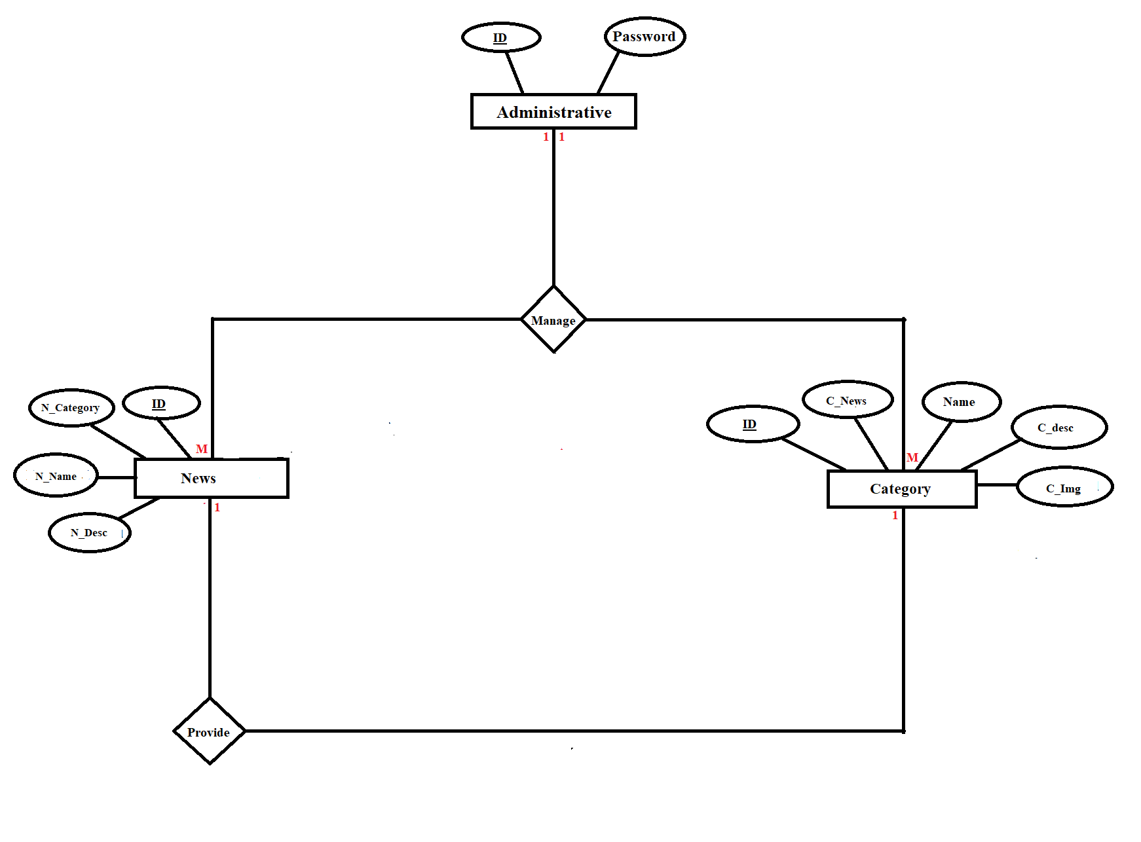

**UML DIAGRAM**

1. **Activity Diagram :**

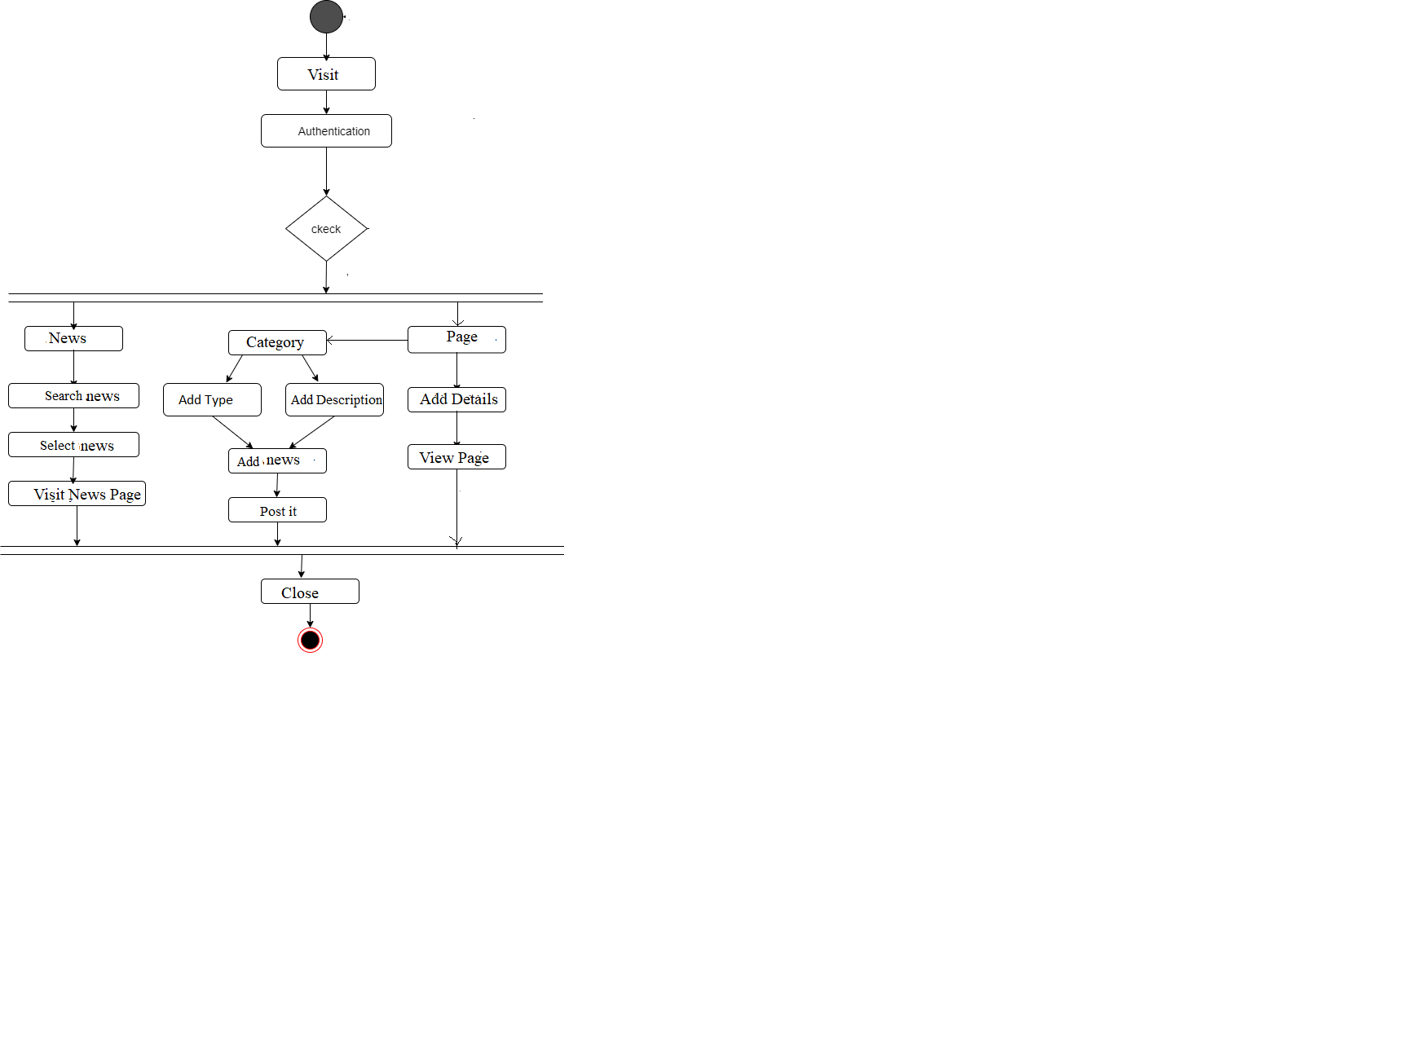

1. **Component Diagram :**

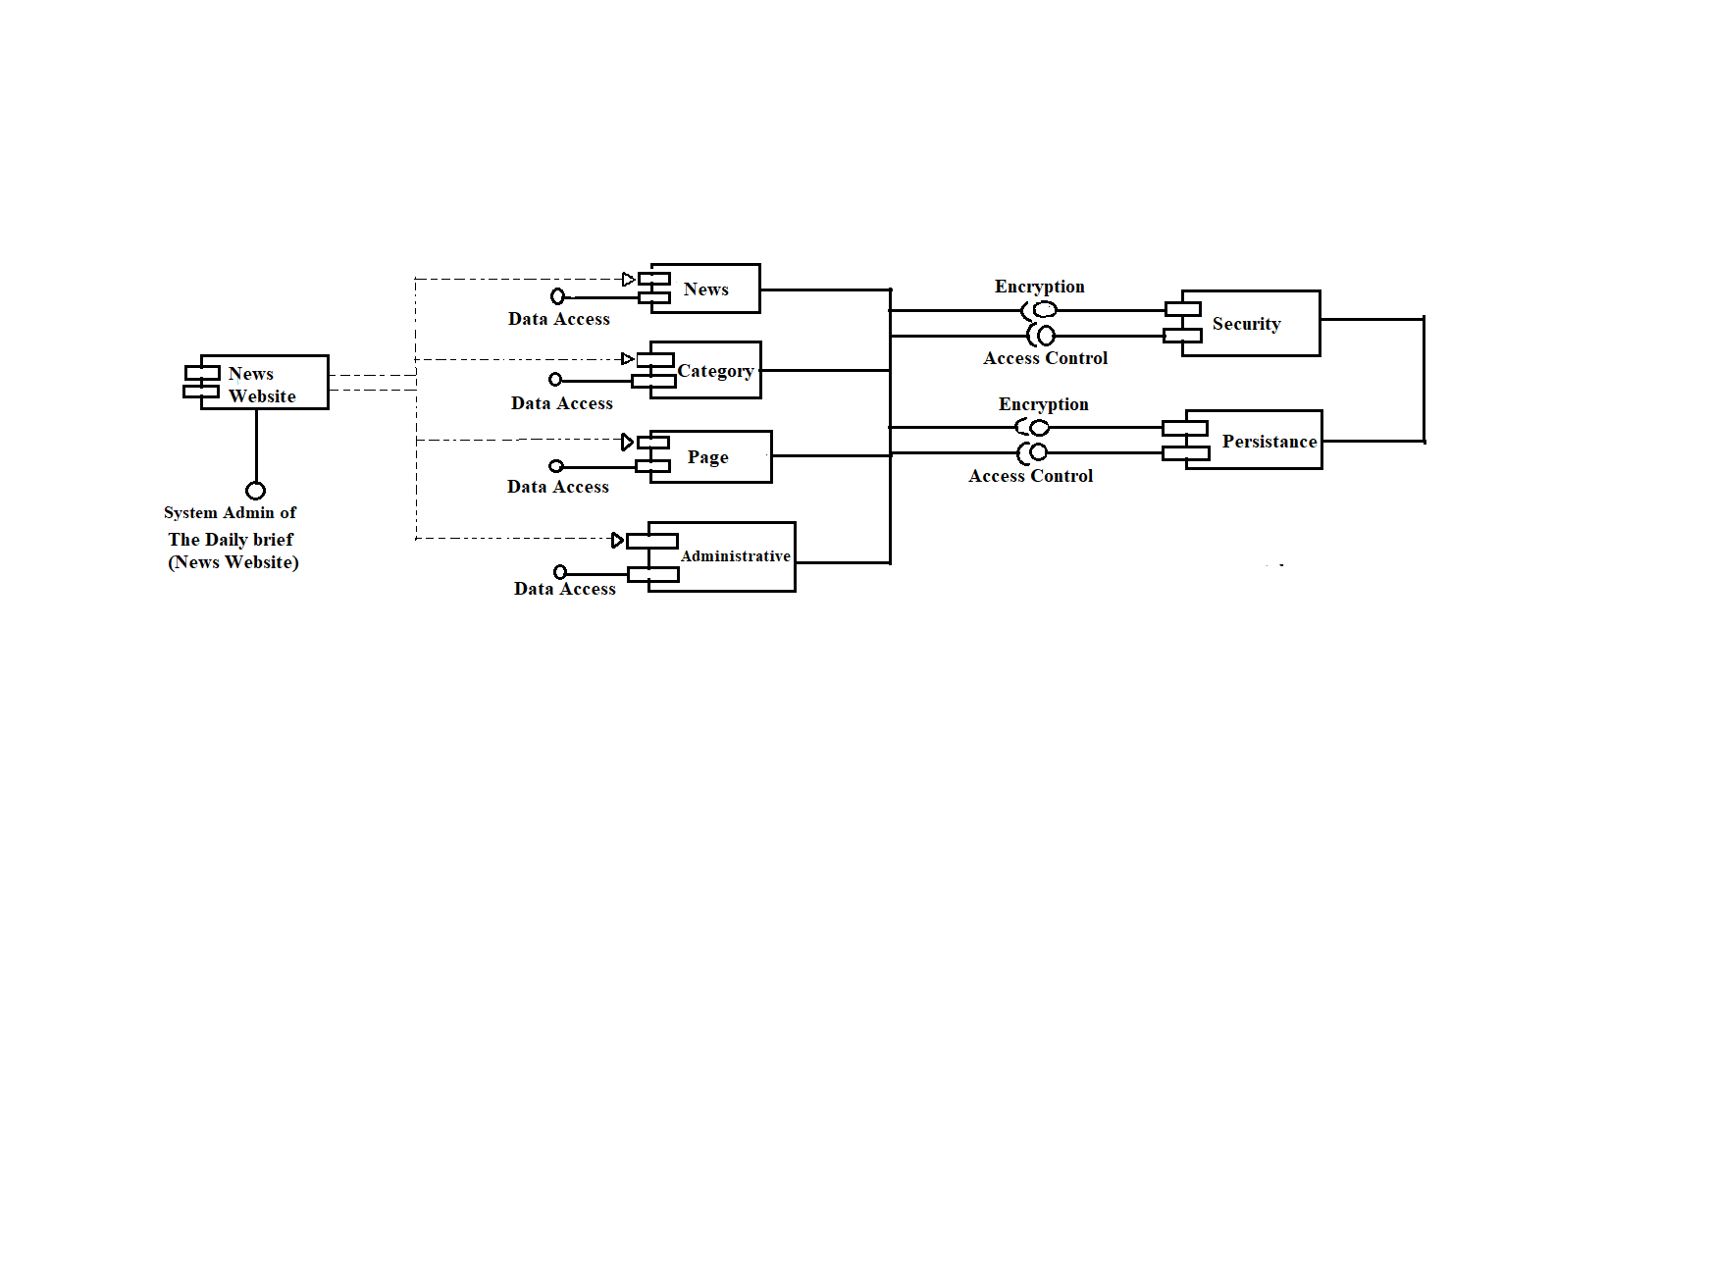

1. **Use- Case Diagram :**

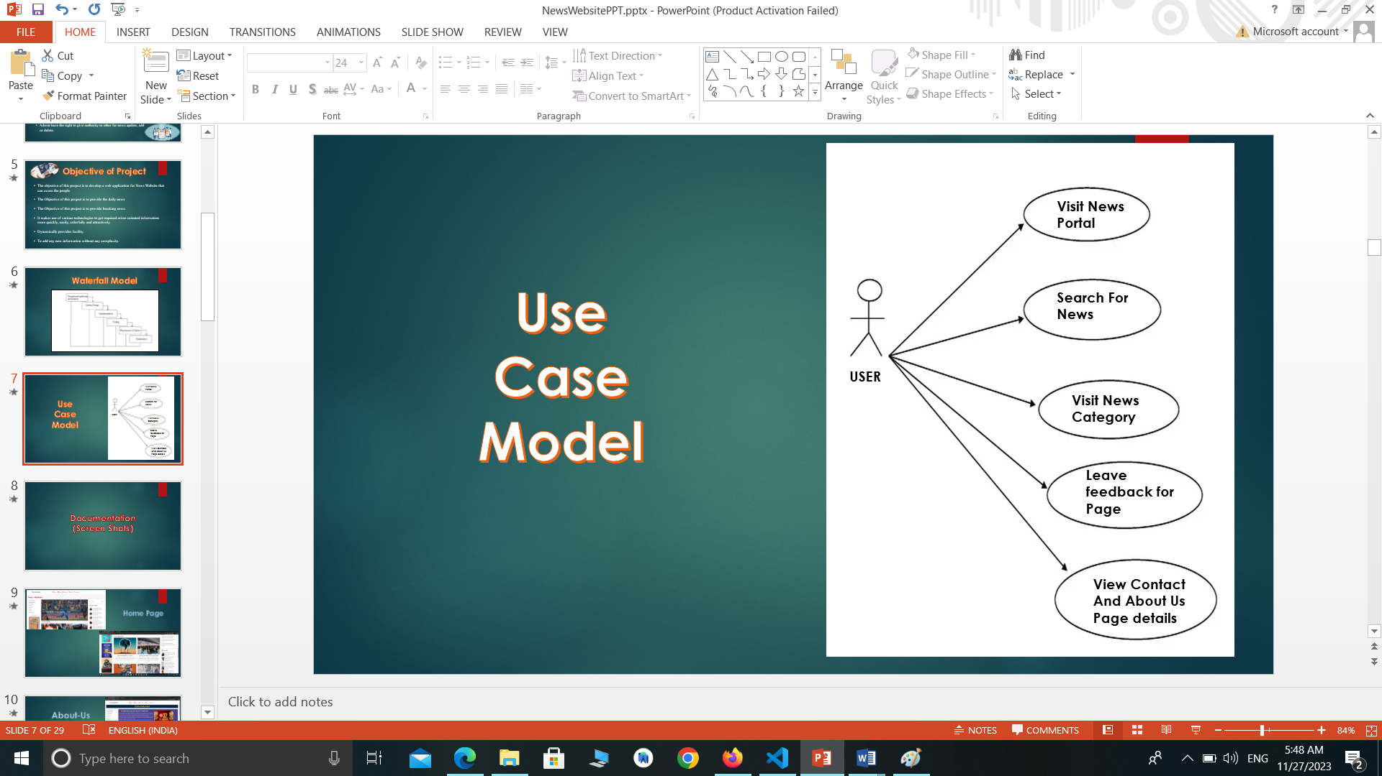

1. **Waterfall Diagram :**

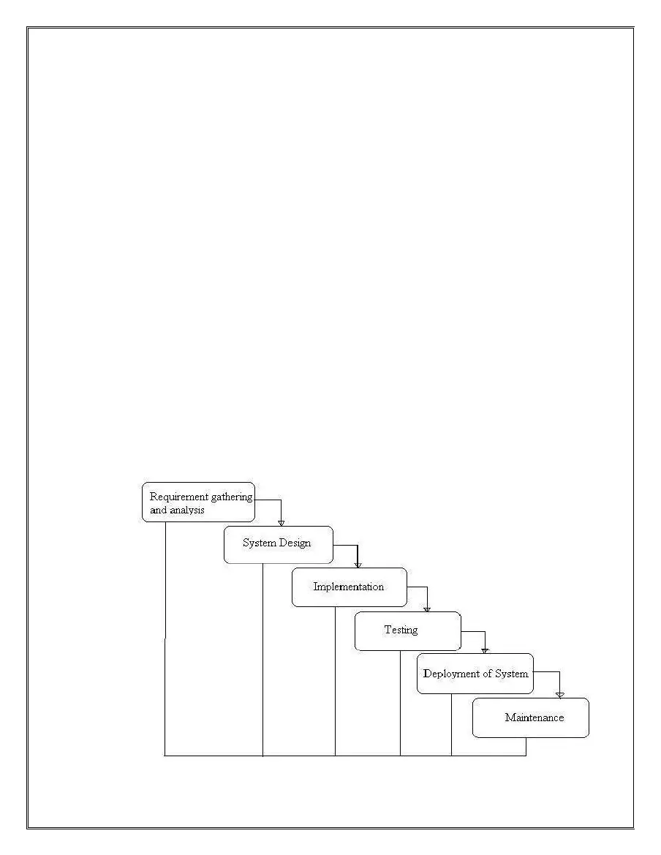

**USER MANUAL**

First step is that people or candidate can easily access the website because it does not have any registration and login window. So User can freely access the news website to view different kinds of news and view the article.

After that there is a menu section in which you can see different menus. Each menu has its own unique page with different kinds of information. Like if you click on home page they can show all the news, videos, images, article and advertisement with specific structure.

In the About us Page there is an information about the website like when it created and charity and many more details about News website. In the contact us page there any address of the main branch office also various details about website. In the live news Section you can see some live news according to daily report.

You can also review the page by clicking review section. In that different user review about website.

Then you can go to the category section. In that you can see different types of category like Entertainment, Lifestyle, Sports, Political, Education, Spiritual, Technology. You can view the different news about different categories. Each Category has its own page.

**DOCUMENTATION (SCREEN LAYOUT)**

* **Home Page :**

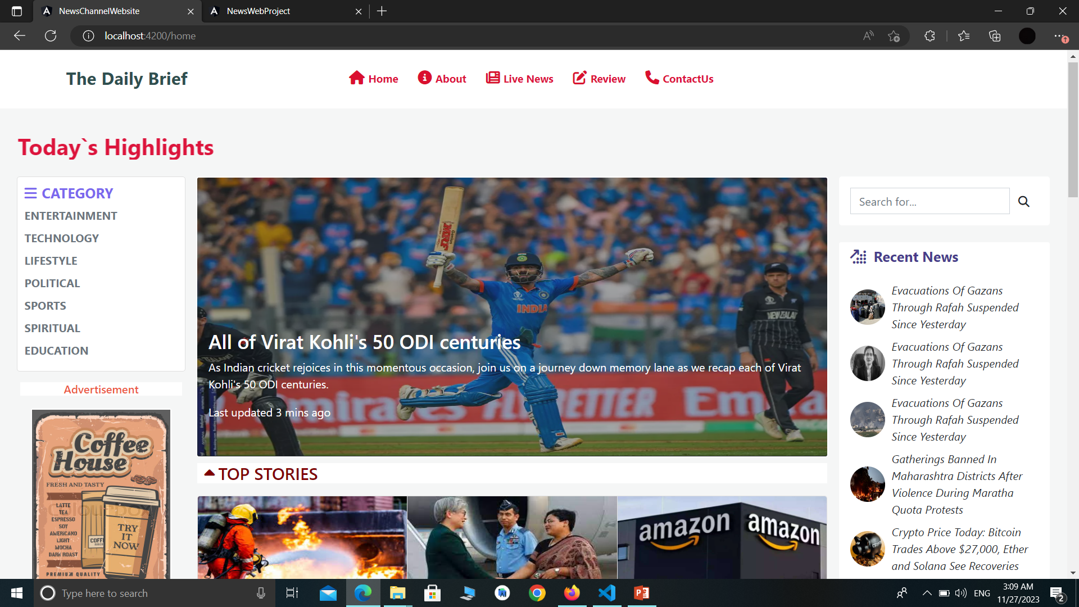

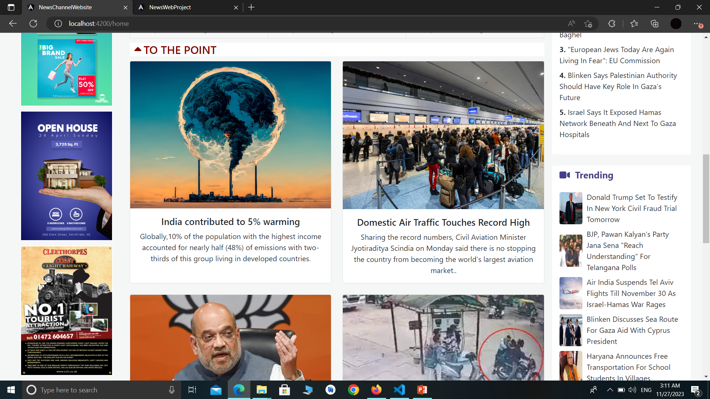

* **About – Us Page :**

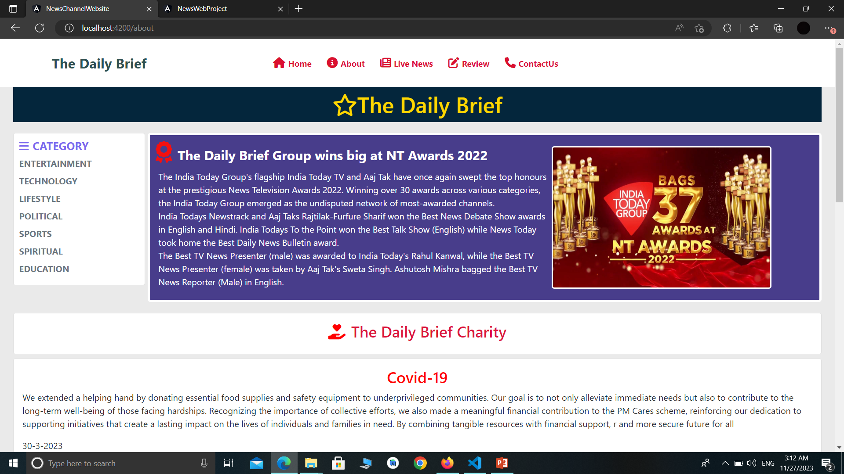

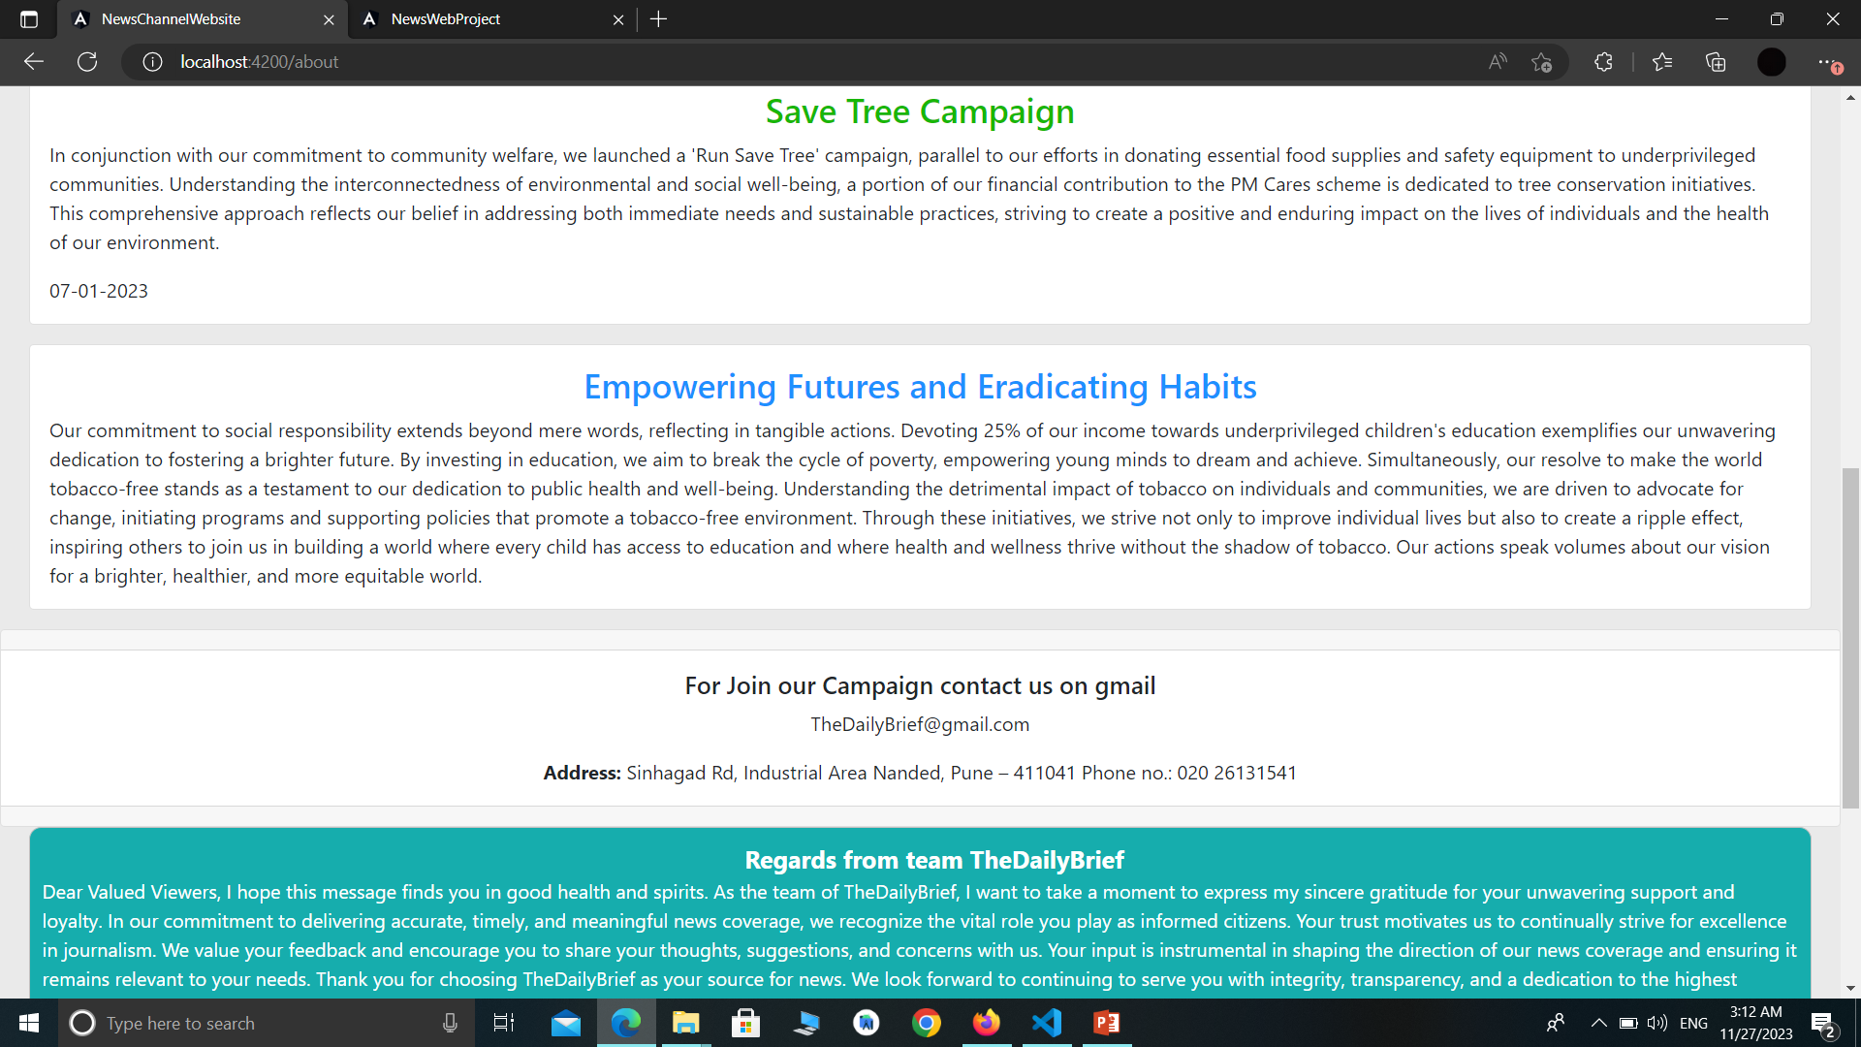

* **Live News**

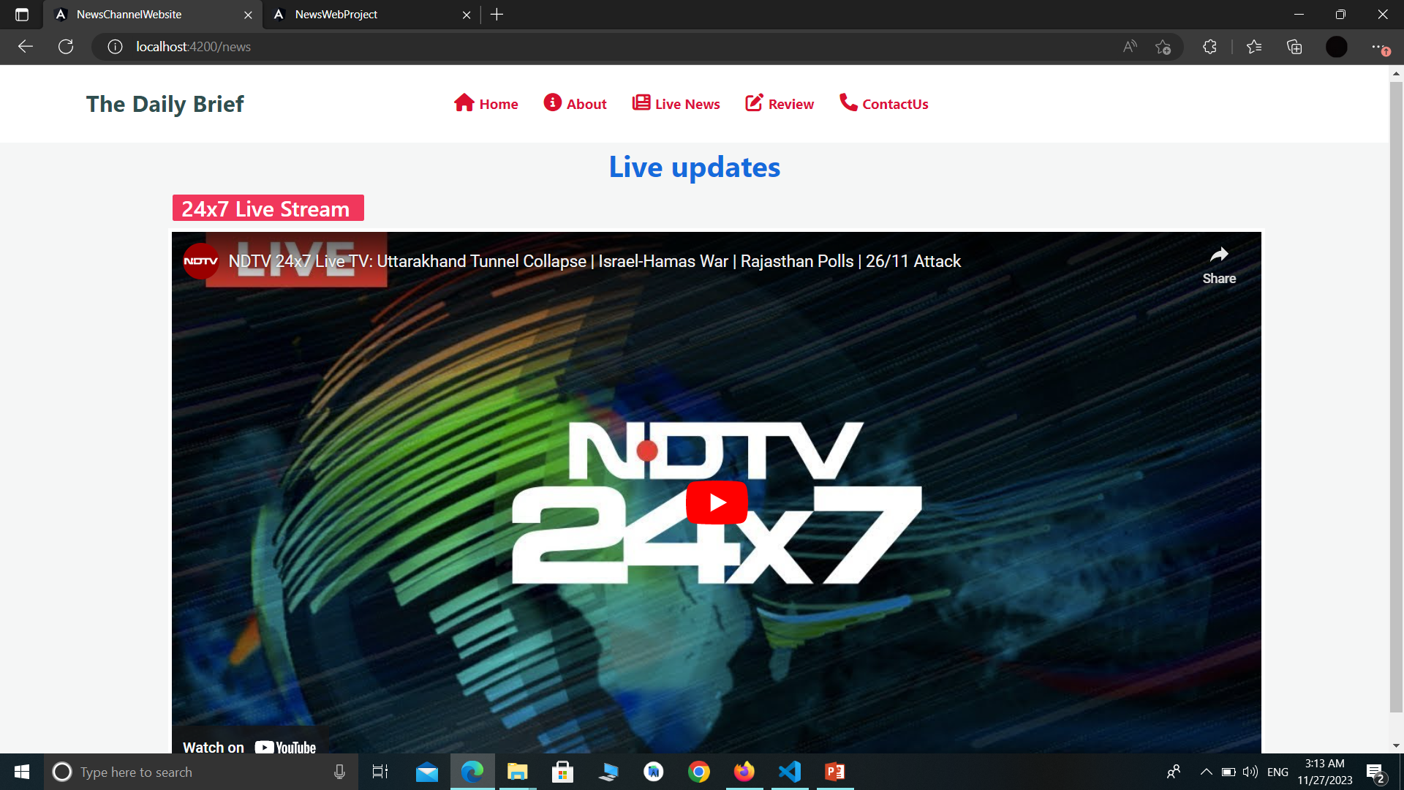

* **Review :**

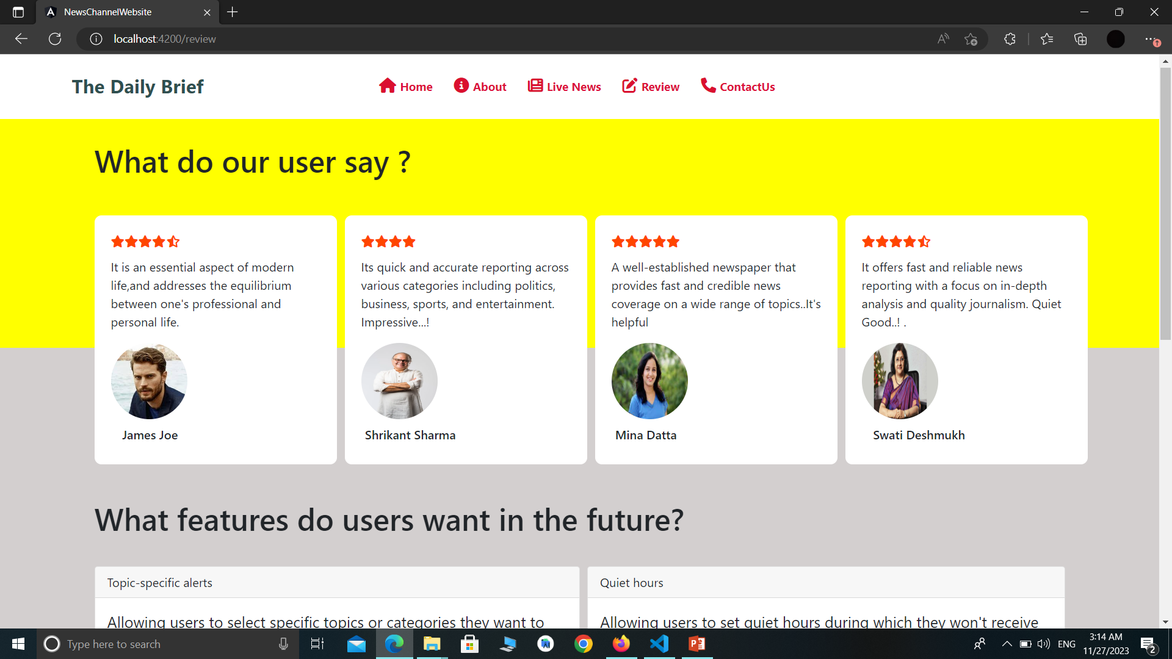

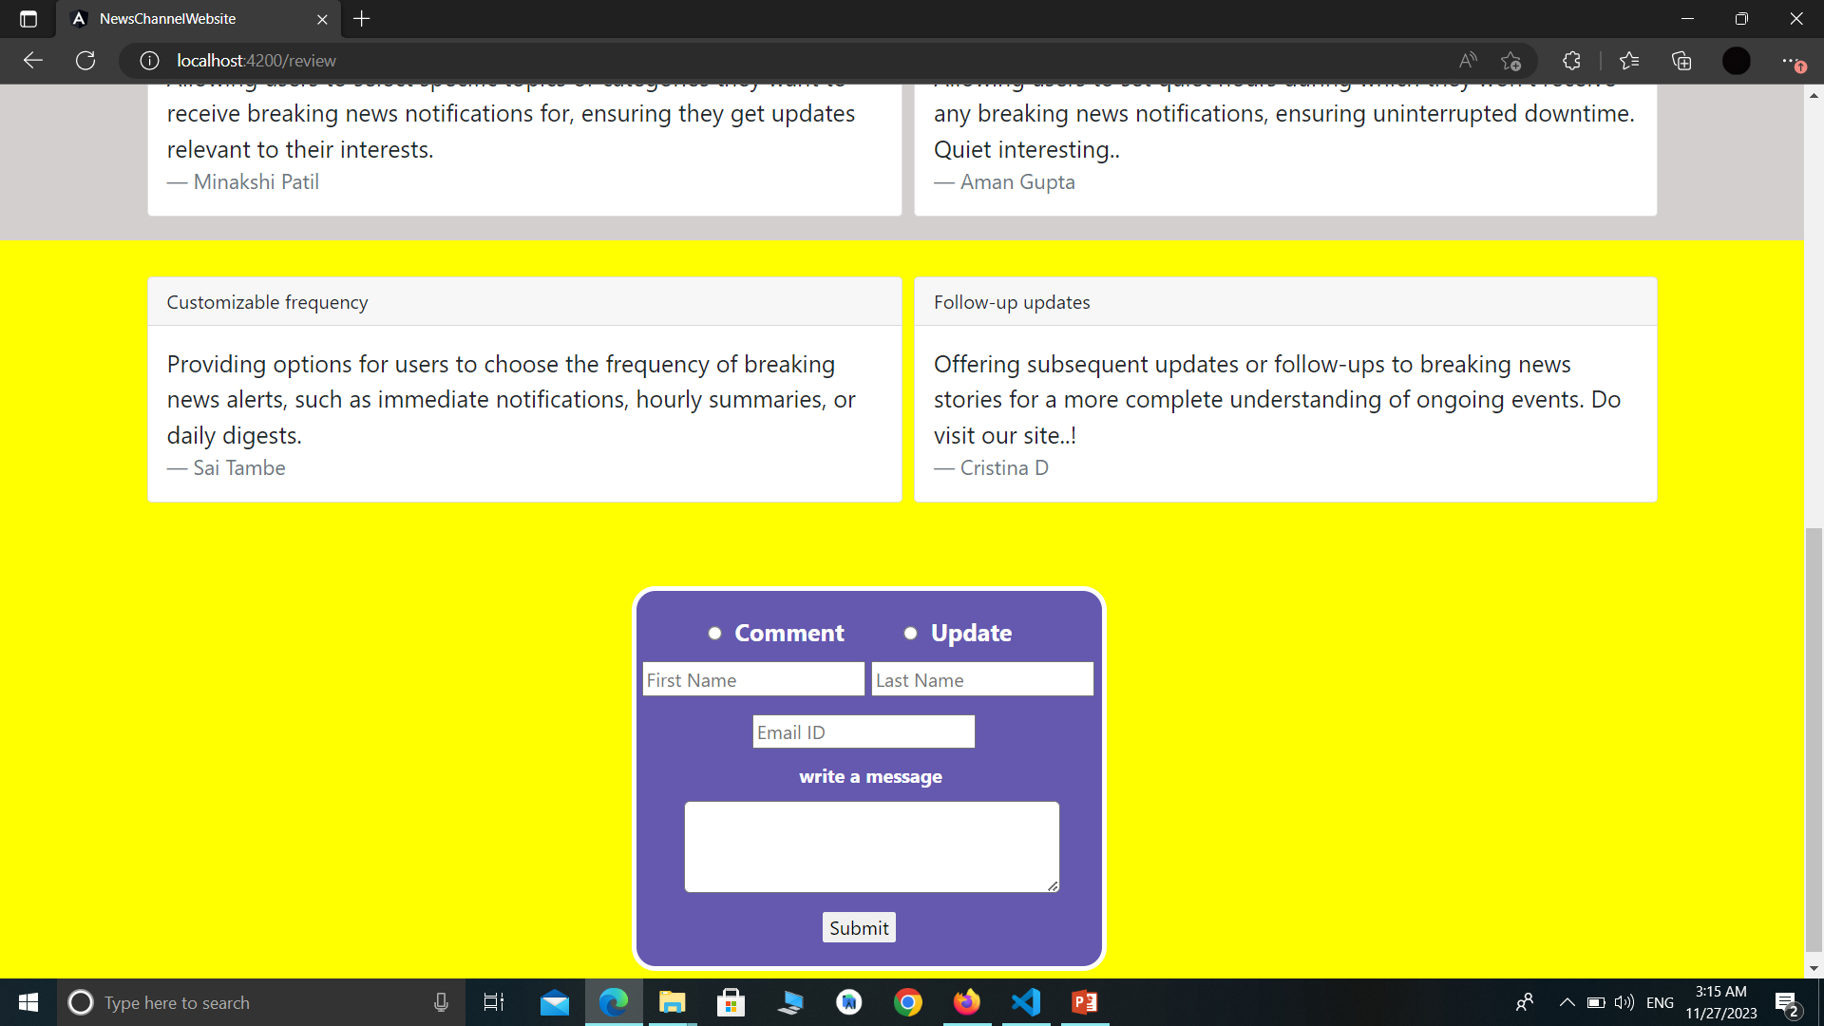

* **Contact-us page :**

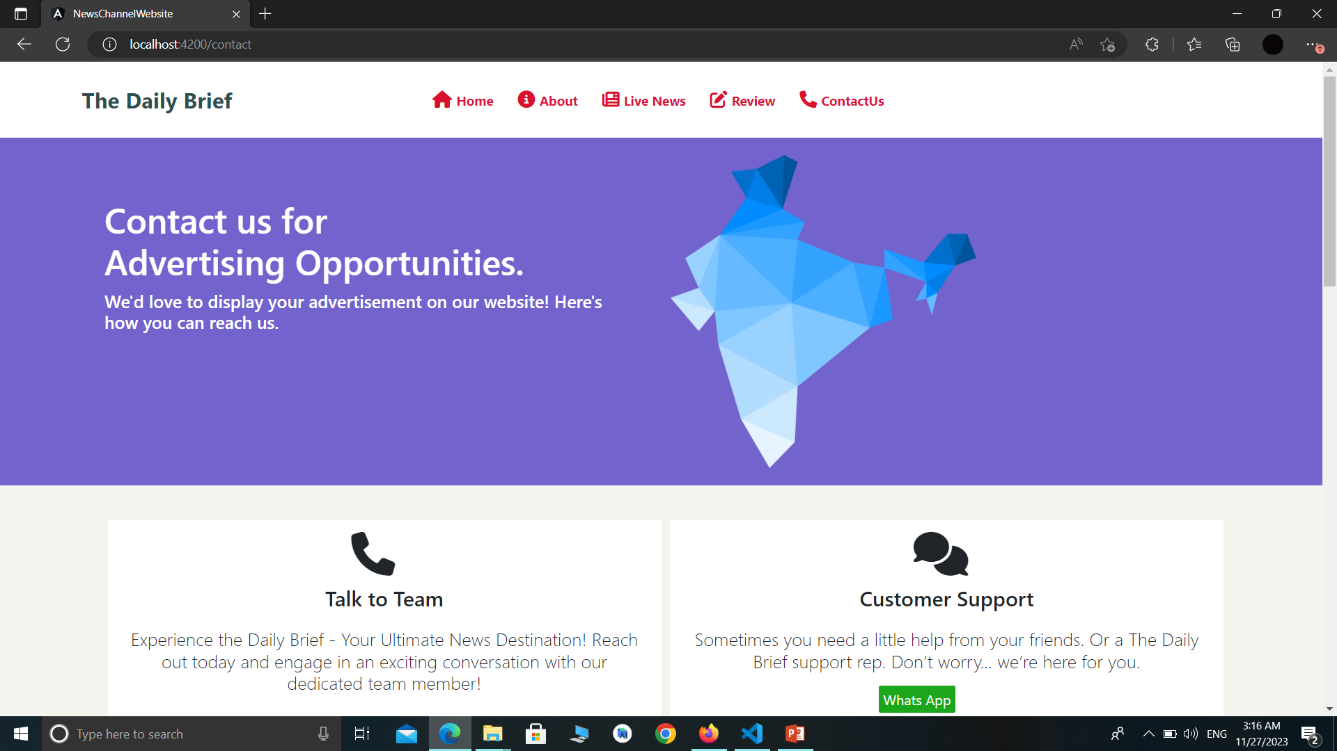

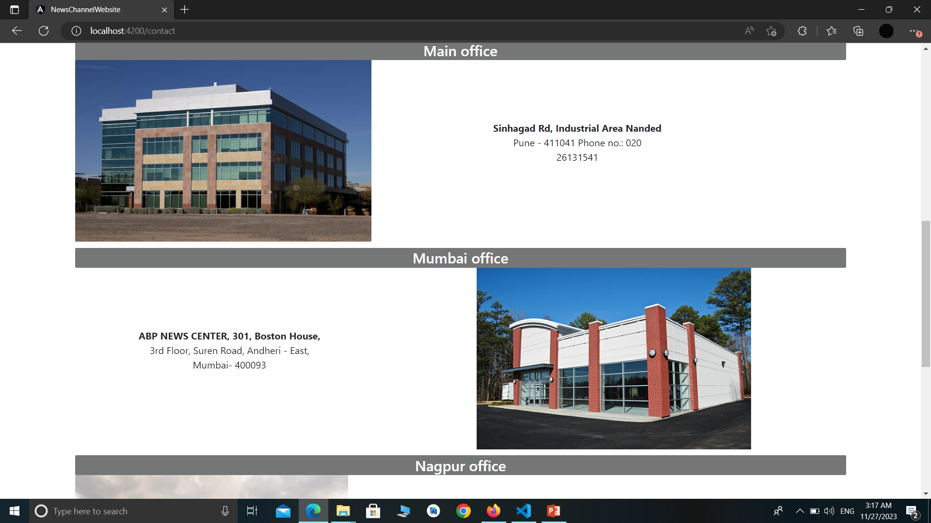

* **Entertainment Category :**

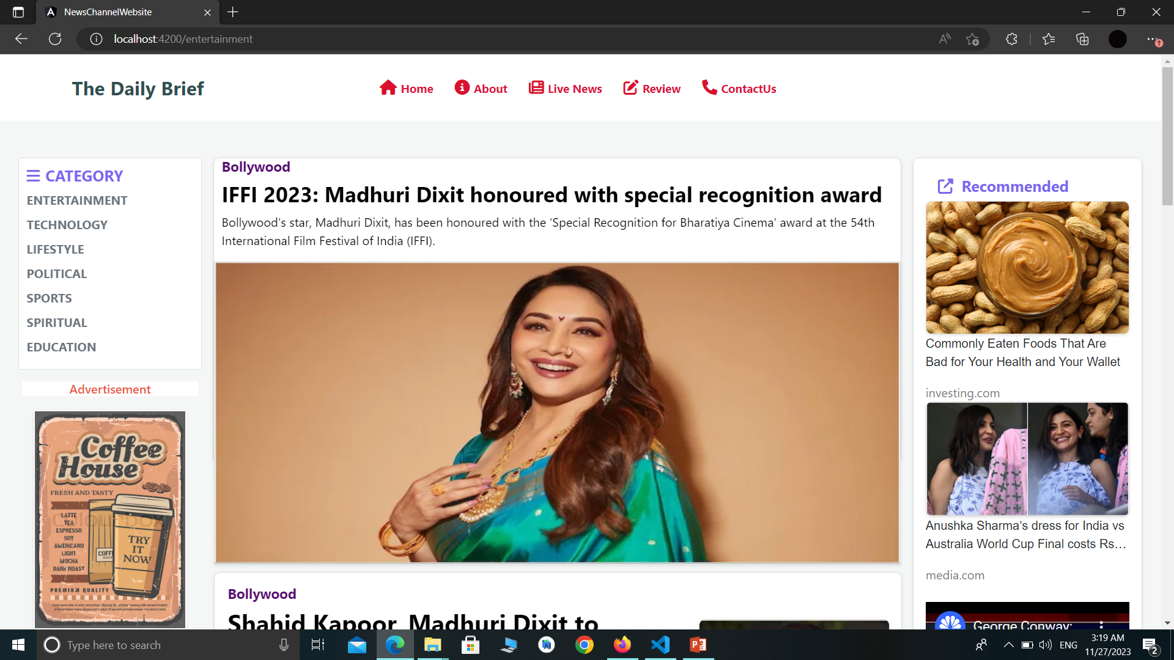

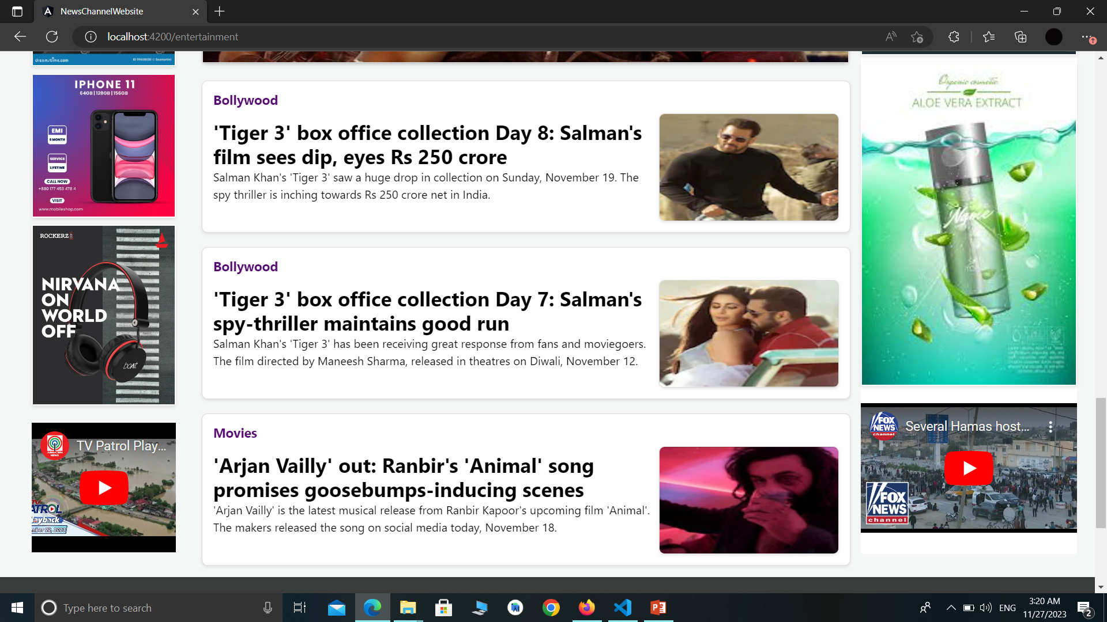

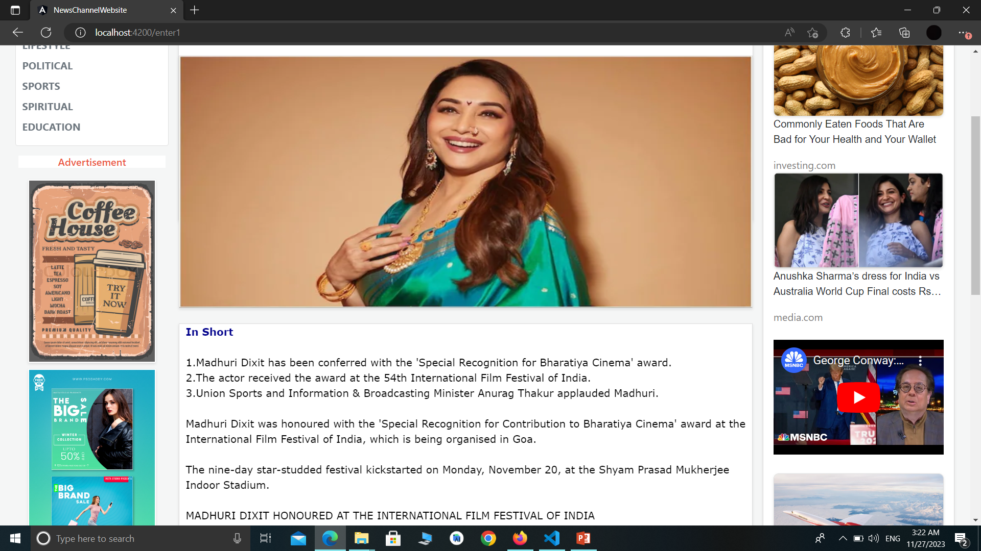

* **Sports Category :**

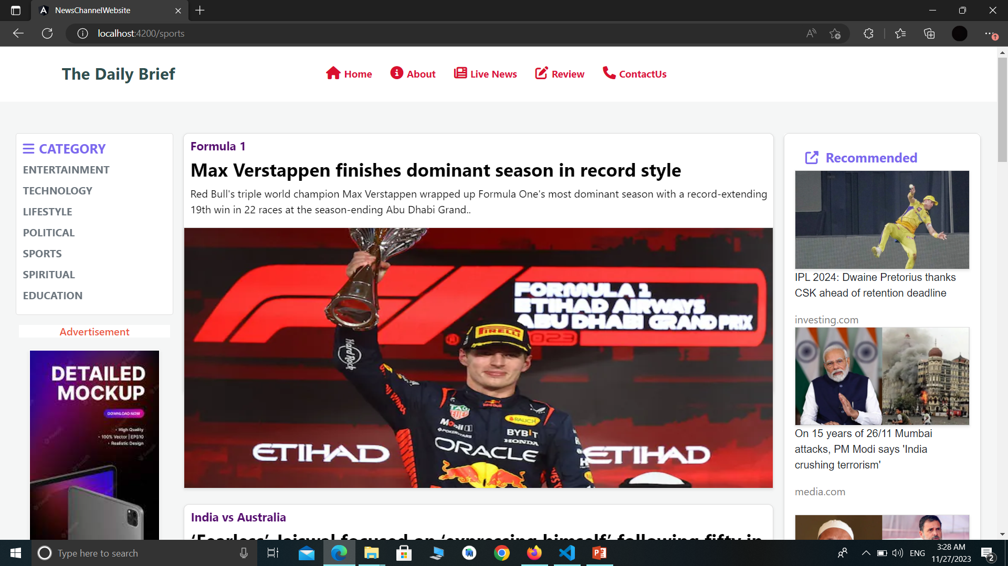

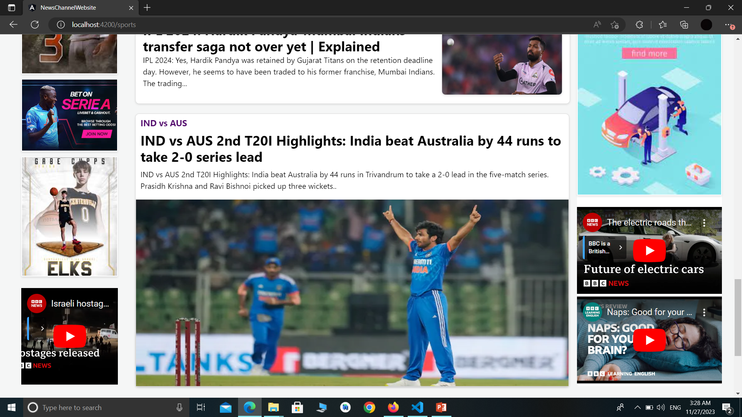

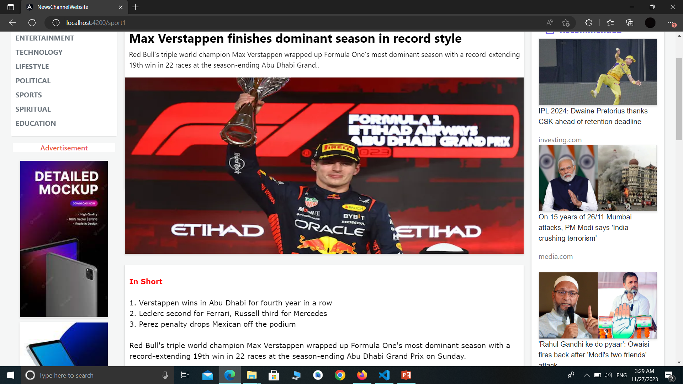

* **Education Category :**

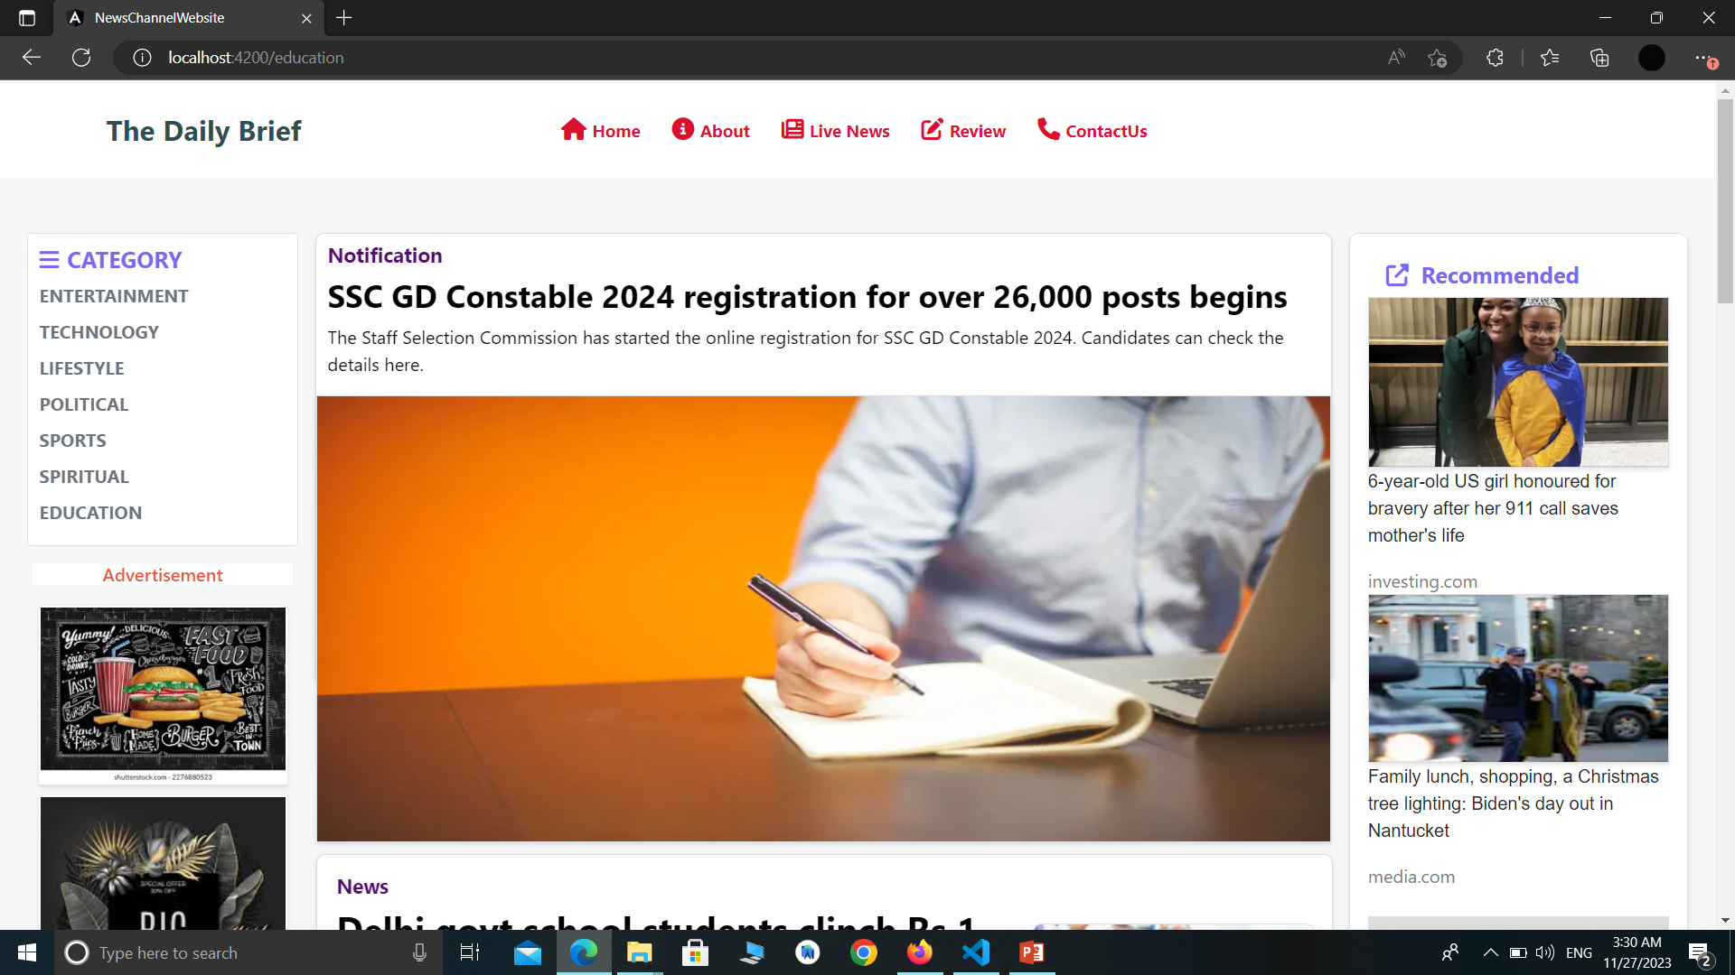

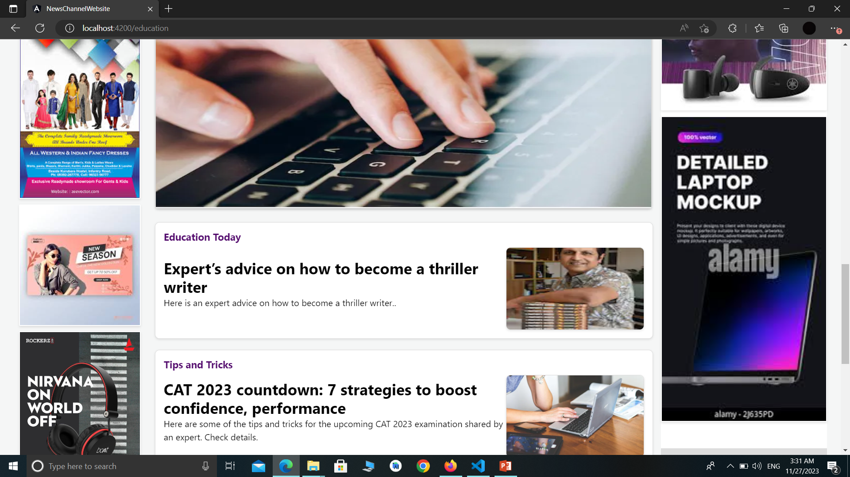

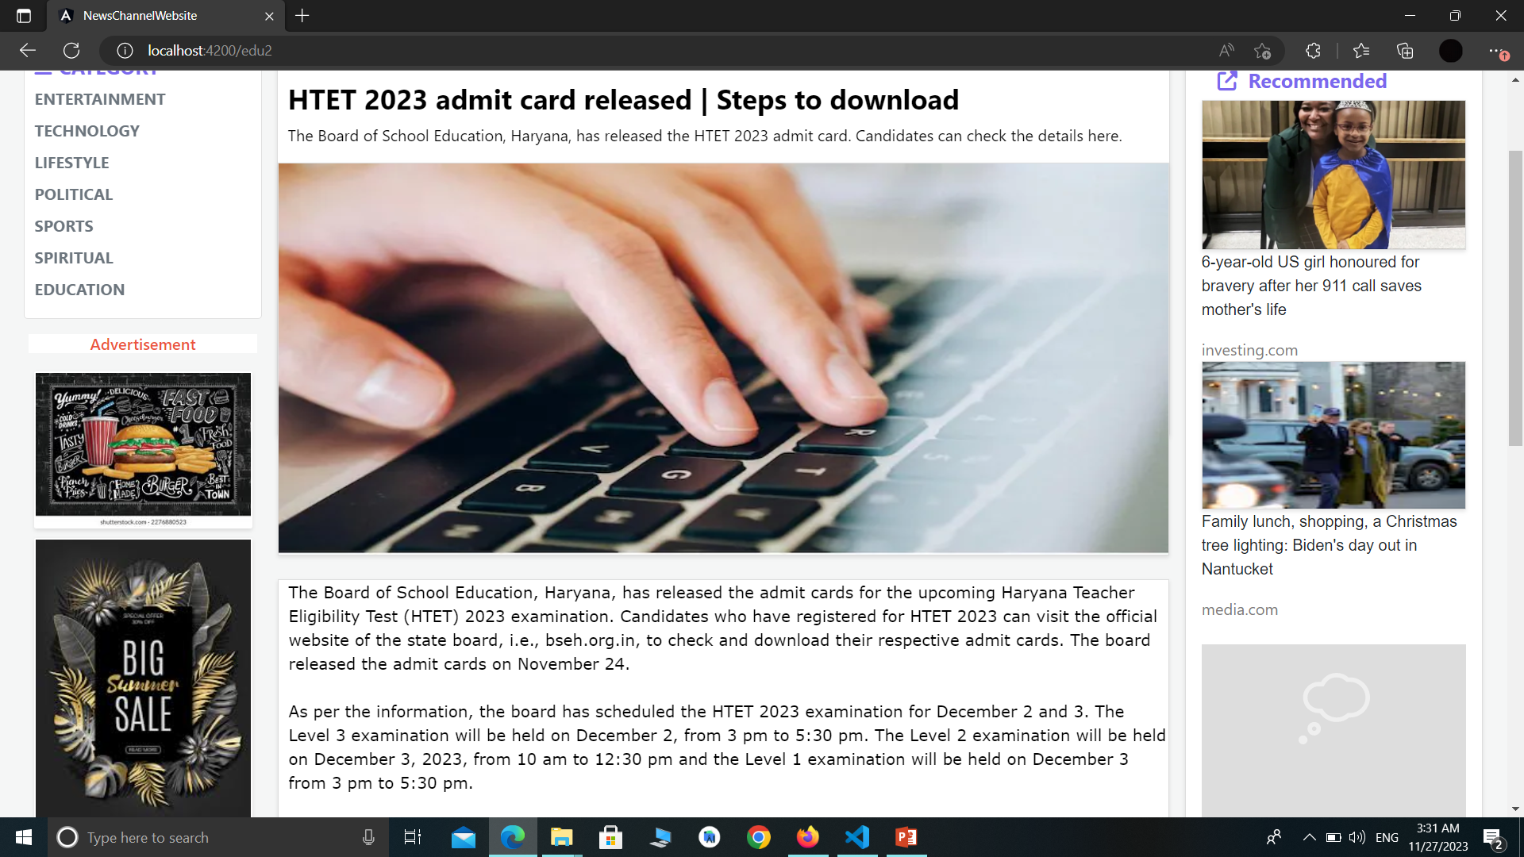

* **Political Category :**

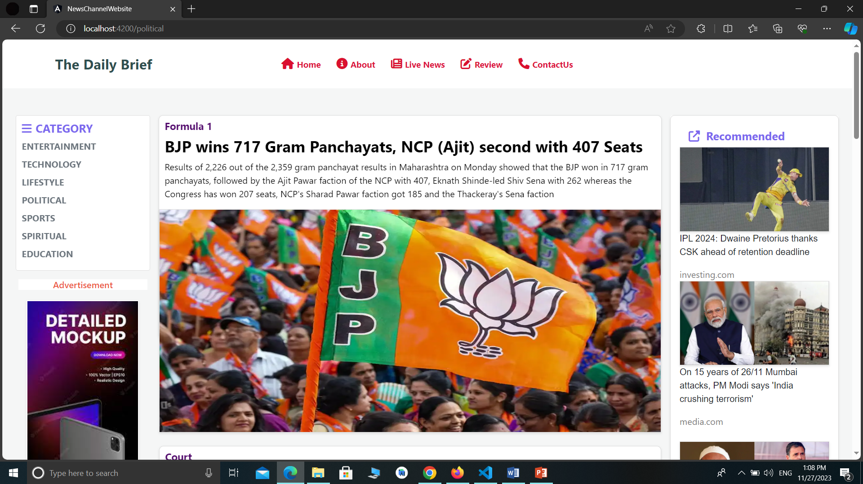

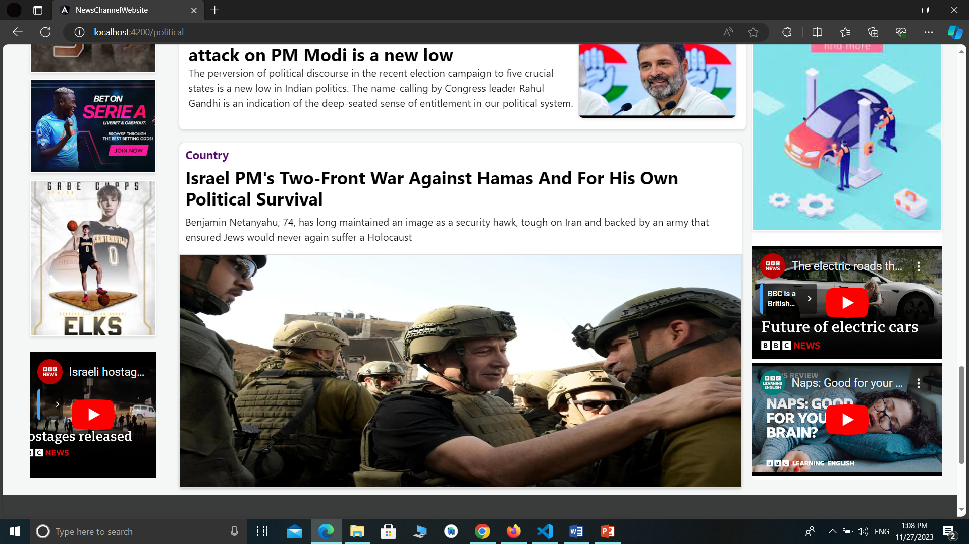

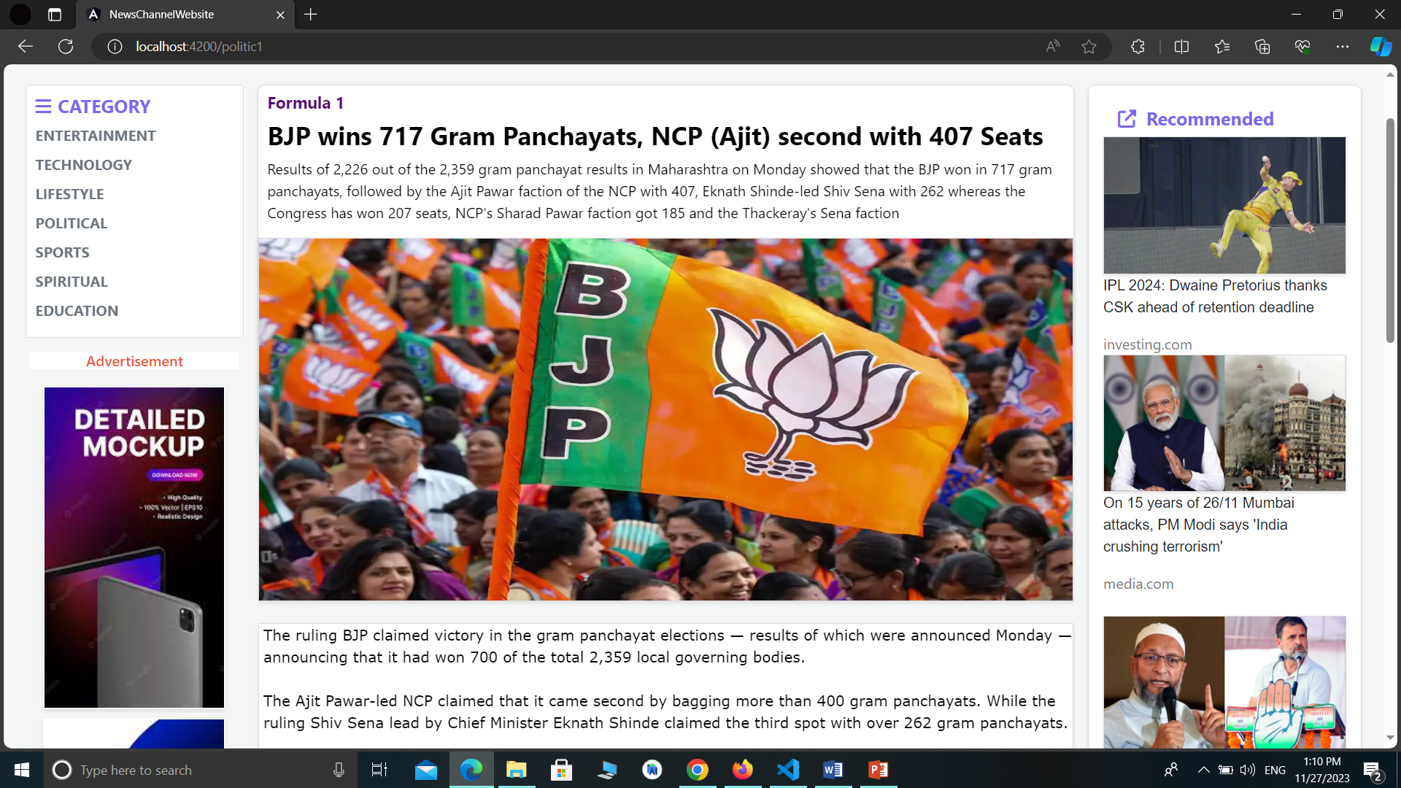

* **Spiritual Category**

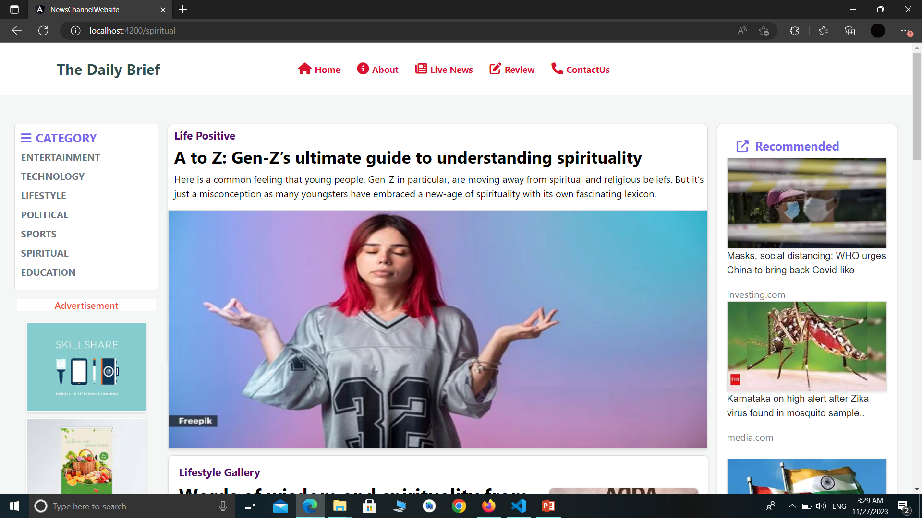

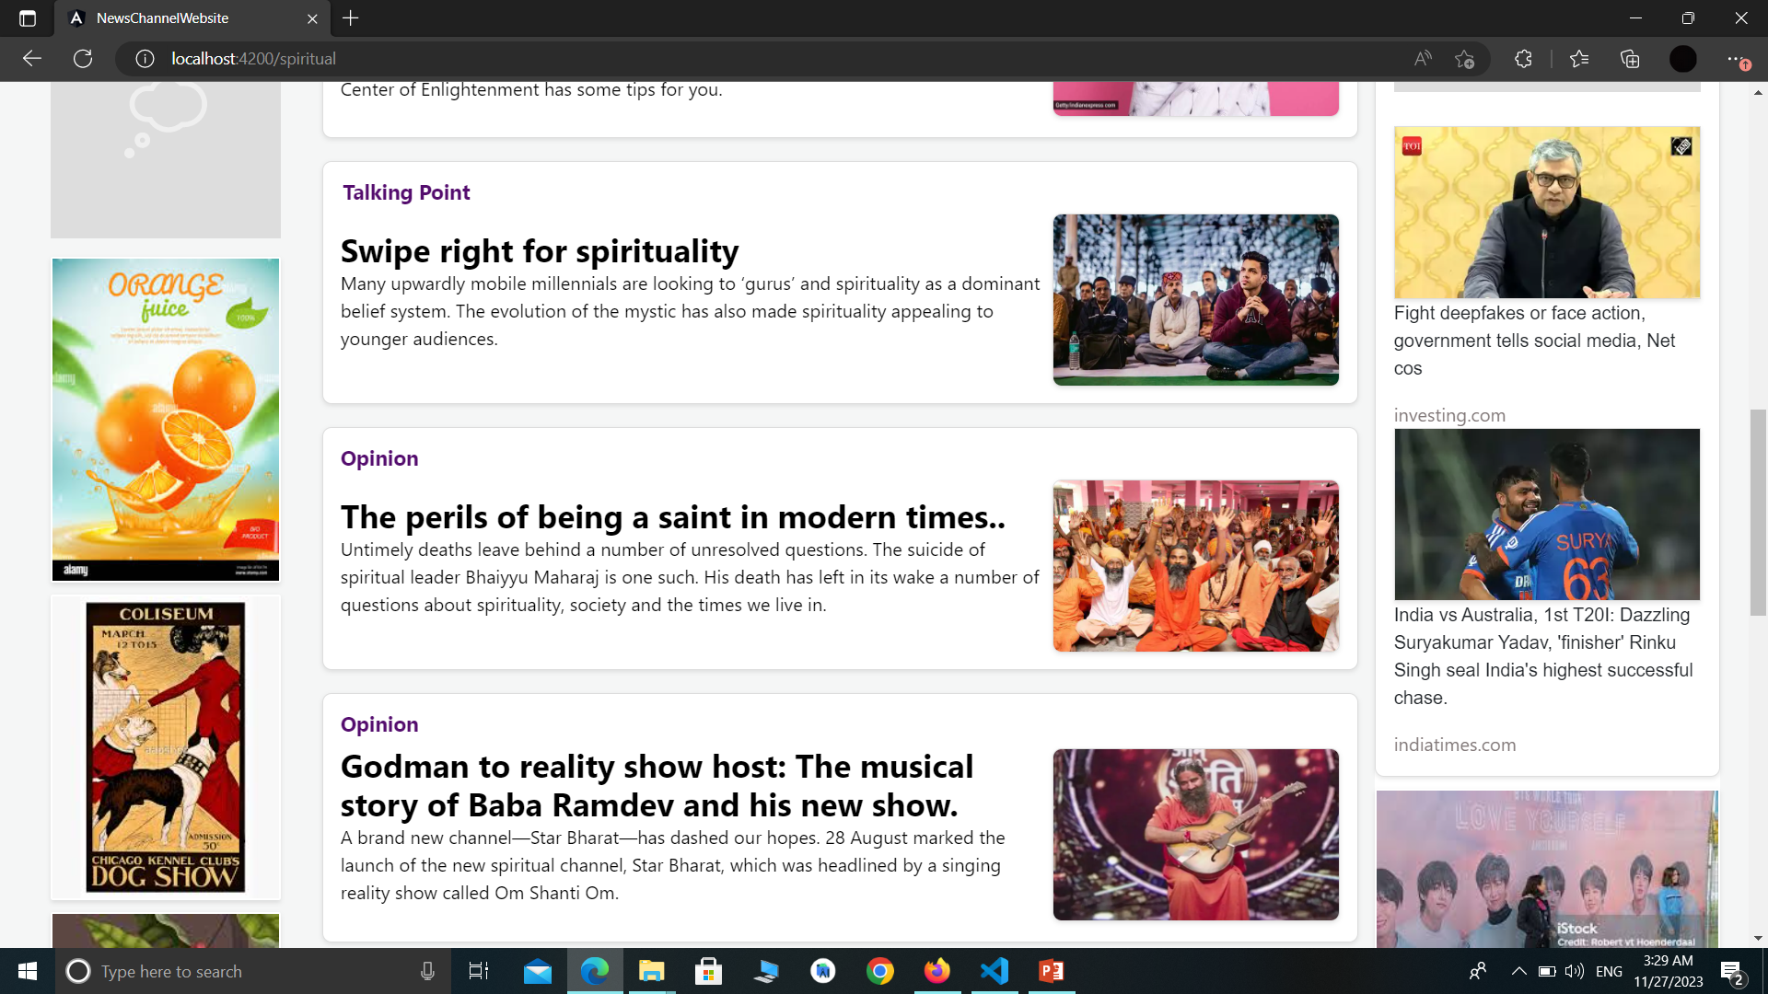

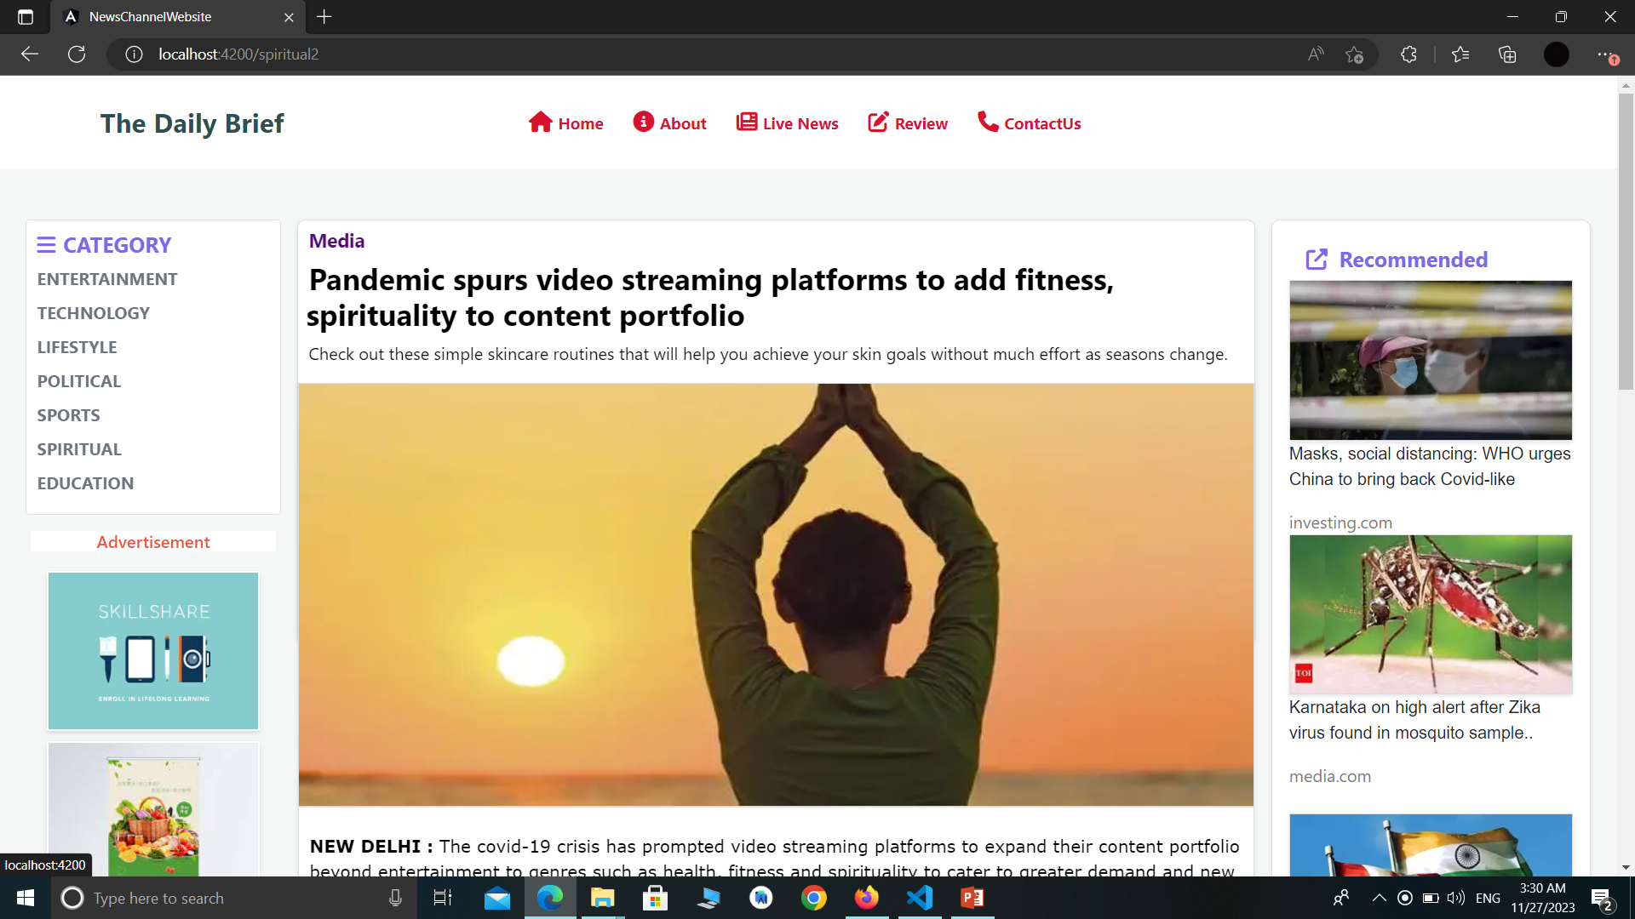

* **Lifestyle Category :**

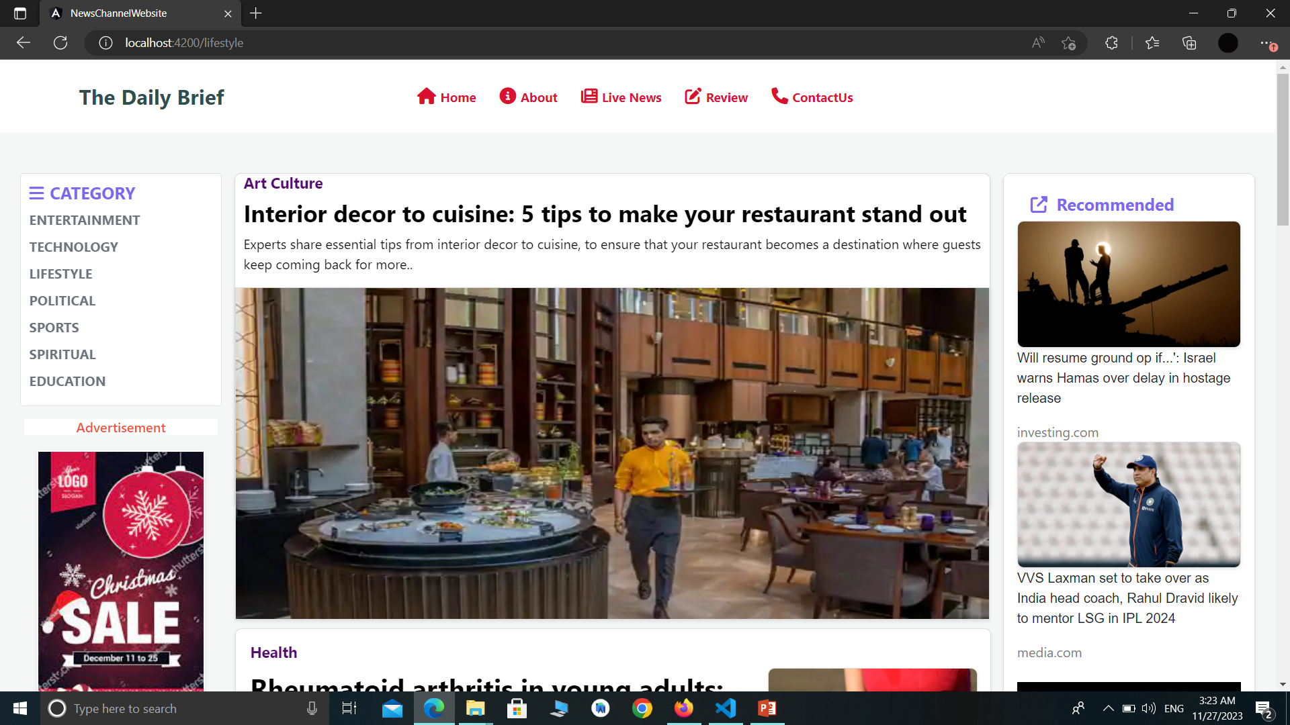

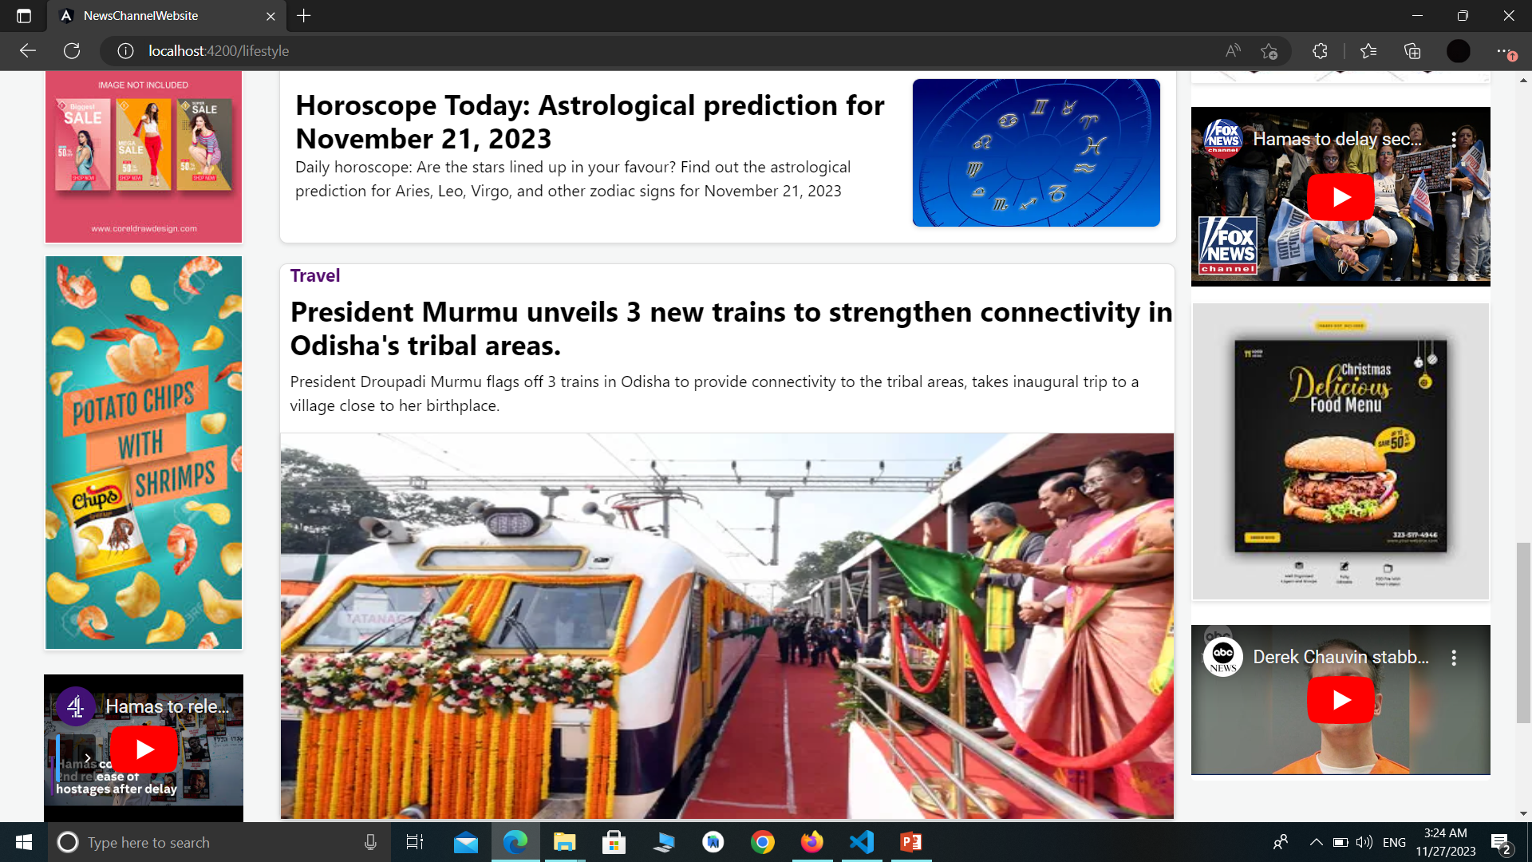

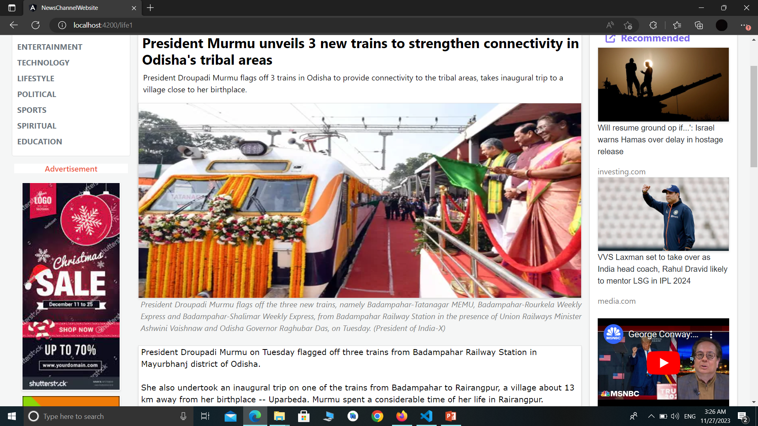

* **Technology Category :**

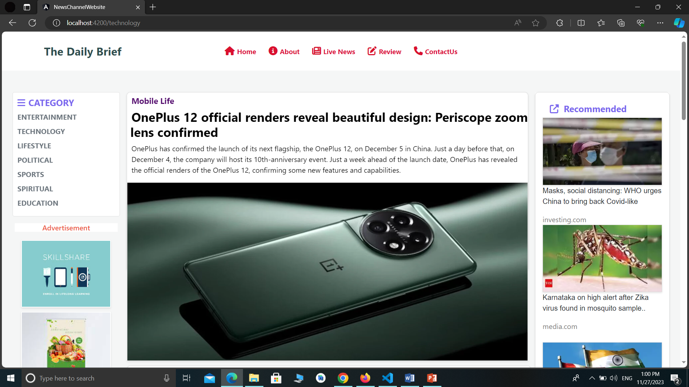

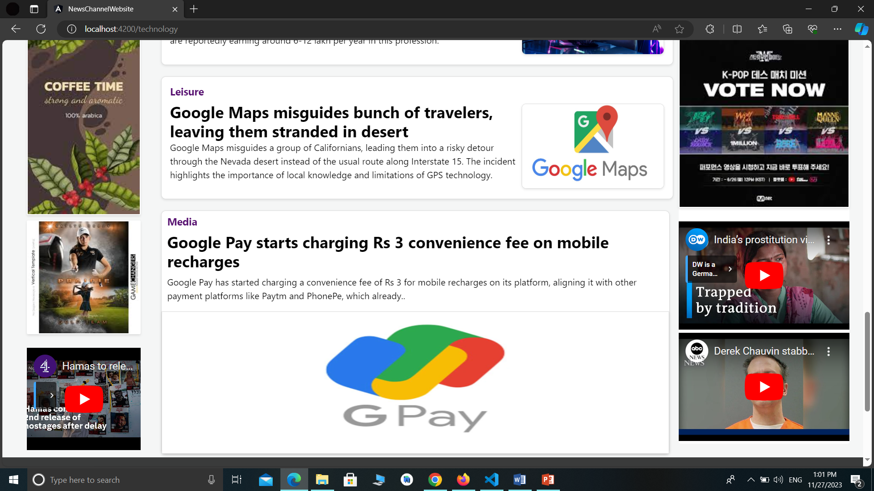

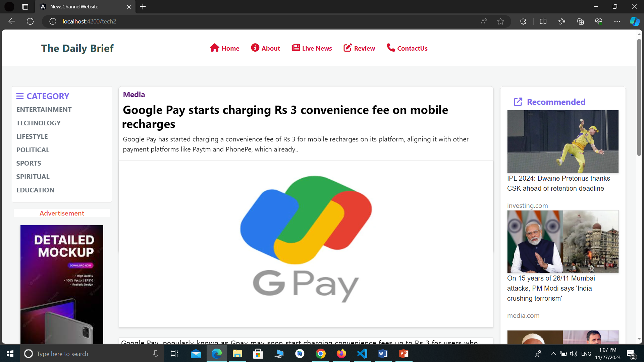

**SYSTEM TESTING**

**SOFTWARE TESTING TECHNIQUES:**

Software testing is a critical element of software quality assurance and represents the ultimate review of specification, designing and coding.

**TESTING OBJECTIVES:**

1. Testing is process of executing a program with the intent of finding an error.
2. A good test case design is one that has a probability of finding an as yet undiscovered error.
3. A successful test is one that uncovers an as yet undiscovered error.

These above objectives imply a dramatic change in view port.

Testing cannot show the absence of defects, it can only show that software errors are present.

There are three types of testing strategies

1. Unit test
2. Integration test

3. Performance test

**UNIT TESTING:**

Unit testing focuses verification efforts on the smallest unit of software design module. The unit test is always white box oriented. The tests that occur as part of unit testing are testing the module interface, examining the local data Structures, testing the boundary conditions, execution all the independent paths and testing error-handling paths.

**INTEGRATION TESTING :**

Integration testing is a systematic technique or construction the program Structure while at the same time conducting tests to uncover errors associated with interfacing. Scope of testing summarizes the specific functional, performance, and internal design characteristics that are to be tested. It employs top-down testing and bottom-up testing methods for this case.

**PERFORMANCE TESTING:**

Timing for both read and update transactions should be gathered to determine whether system functions are being performed in an acceptable timeframe.

**DRAWBACKS AND LIMITATIONS**

1. The current system is very time consuming.
2. We don’t manage news reporting system.
3. System break down makes staff work to stop.
4. Improper coding of the system damages the business.
5. Sensibility level could not add.
6. The System being large has its flaw of maintenance.
7. As due to large Size the maintenance of the System in the Long run becomes difficult
8. Attention And Emotional Development
9. It is not suitable application for emergency needs.

**FUTURE SCOPE AND EVALUATION**

* Add service like online payment for User who make Advertise.
* This application can easily implemented under various situation.
* We can add new features as and when we requires.
* Reusability of this application is also possible.
* We will manage news reporting system.
* We make video conferencing system.
* We update new database feature.
* Sensibility level could be added
* This application can easily implemented under various situation.

**CONCLUSION**

It has been a matter of immense pleasure, honour and challenge to have this opportunity to make up this project and complete it successfully.

While developing this project I have learn a lot about The Daily brief (News Website) , I have also learn how to make its user friendly (easy to use and handle) by hiding the complicated parts of it from the users.

During the development process I studied carefully and understand the criteria for making the software more demanding. I also realized the importance of maintaining a minimal margin for error. This system is secure and scalable.

It has been a great pleasure for me to work on this exciting and challenging project. This project proved good for me as it provided practical knowledge of not only programming in Front End web based application and no some extent Windows Application but also about all handling procedure related with “THE DAILY BRIEF”. It also provides knowledge about the latest technology used in developing web enabled application and client server technology that will be great demand in future. This will provide better opportunities and guidance in future in developing projects independently

**BIBLIOGRAPHY**

**Websites Reference :**

* [**www.wikipedia.com**](http://www.wikipedia.com/)
* [**www.slideshare.net**](http://www.slideshare.net/)
* [**www.sourcecodester.com**](http://www.sourcecodester.com/)
* [**www.w3schools.com**](http://www.w3schools.com/)
* [**www.pdfsearchengine.com**](http://www.pdfsearchengine.com/)
* [**www.webcode.com**](http://www.webcode.com)
* [**http://www.bestjobs.ph**](http://www.bestjobs.ph)
* **http://www.gopinoy.com**
* **http://www.jobsdb.com.ph**
* [**http://www.jobsonline.com.ph**](http://www.jobsonline.com.ph)
* **http://www.jobstreet.com.ph**
* **http://www.phil-job.net**